Economic growth

- Economic growth GSP $26.1 billion
- NT estimated growth rate in 2022-23 is -5.1%
- NT forecasted growth rate:
  - 2023-24 is 2.7%
  - 2024-25 is 2.1%
- National growth rate in 2021-22 is 3.7%

Industry share of output top 5
The top 5 industry share of NT’s output are:
- Mining is 22.0%
- Public admin is 11.9%
- Health is 8.7%
- Construction is 5.9%
- Education is 5.3%

State Final Demand

- State Final Demand as of March 2023 is $7.1 billion, up by 1.3% compared to March 2022
- Annual change (%) of State Final Demand components:
  - Public investment, up 13.6% to $0.5 billion
  - Private business investment, up 5.8% to $1.3 billion
  - Household consumption, up 0.1% to $2.8 billion
  - Government consumption, down 1.4% to $2.6 billion

Business confidence for the Northern Territory

- Business confidence for the Northern Territory is +43% in the June 2023 quarter, down 25 percentage points from the previous quarter
- Business count as at June 2023 for the Northern Territory was 16 107, up 311 businesses over the year to June 2023

Darwin inflation

- Darwin inflation increased to 5.3% annually in June 2023
- National inflation increased to 6.0%
- Trimmed mean increased to 5.9%

Labour market

- Unemployment rate is 3.9% as of July 2023, up by 0.2 percentage point
- Employment is 137 981 as of July 2023 up by 0.9% annually.
- Participation rate is 73.0% as of July 2023, annual decrease of 0.1 percentage point

NT population
- NT population is 250 149, up 0.8% compared to December 2021
- National population is 26.3 million, up 1.9% compared to December 2021

Population distribution
- Population distribution:
- Greater Darwin was 149 582 up by 0.5%
- East Arnhem was 14 589 up by 0.5%
- Katherine was 21 335 up by 0.9%
- Alice Springs was 41 043 up by 0.9%
- Barkly was 6033 up by 0.2%
- Daly-Tiwi-West Arnhem was 18 120 up by 0.5%

Average weekly earnings

- Average weekly earnings in the NT is $1 891 as of May 2023, annual increase of 2.4%
- Average weekly earnings nationally is $1 907 as of May 2023, up 3.9% annually
- WPI in the NT increased by 3.3% annually in June 2023 and 3.6% nationally

Median house prices
- Median house prices in the June quarter 2023:
- Greater Darwin $565 000 down 3.6%
- Katherine $460 000 up 21.1%
- Alice Springs $515 000 down 3.0%
- Tennant Creek $260 000 down 11.9%

Business size
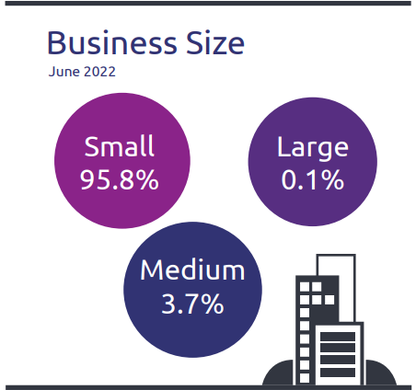

- NT business size:
  - Small is 95.8%
  - Medium is 3.7%
  - Large is 0.1%

Business location
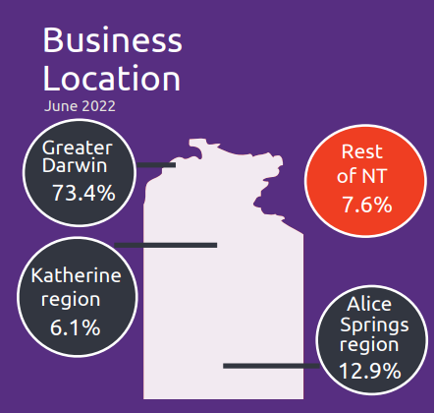

- Businesses by location:
- Greater Darwin has 73.4%
- Katherine has 6.1%
- Alice Springs has 12.9%
- Rest of NT has 7.6%

NT Department of Industry, Tourism and Trade
t: 08 8999 5139
industry.nt.gov.au

