Economic growth

- Economic growth GSP $26.1 billion
- NT forecasted growth rate:
  - 2022-23 is 3.7%
  - 2023-24 is -0.7%
  - 2024-25 is 4.3%
- National growth rate in 2021-22 is 3.7%

Industry share of output top 5

- Construction is 5.9%
- Mining is 22.0%
- Public admin is 11.9%
- Health is 8.7%
- Education is 5.3%

State Final Demand

- State Final Demand, up 3.3% to $7.1 billion through the year to December 2022
  - Public investment, up 14% to $0.4 billion through the year to December 2022
  - Private business investment, up 5% to $1.3 billion through the year to December 2022
  - Household consumption, up 0.6% to $2.8 billion through the year to December 2022
  - Government consumption, up 3.9% to $2.5 billion through the year to December 2022

Business confidence for the Northern Territory

- Business confidence for the Northern Territory is +74% in the December 2022 quarter, down 3 percentage points from the previous quarter
- Business count as at June 2022 for the Northern Territory was 15 796, up 849 businesses over the year to June 2022

Darwin inflation

- Darwin inflation increased to 6.2% through the year to March 2023
- National inflation increased to 7.0%
- Trimmed mean increased to 6.6%

Labour market

- Unemployment rate is 3.5% as of March 2023, down by 0.6 percentage point
- Employment is 141 905 up 5.7% through the year to March 2023
- Participation rate is 75.2% as of March 2023, up 2.9 percentage points through the year to March 2023

NT population
- NT population is 250 602, up 0.4% through the year to September 2022
- National population is 26.1 million, up 1.6% through the year to September 2022

Population distribution
- Population distribution:
- Greater Darwin was 149 582
- East Arnhem was 14 589
- Katherine was 21 335
- Alice Springs was 41 043
- Barkly was 6033
- Daly-Tiwi-West Arnhem was 18 120

Average weekly earnings

- Average weekly earnings in the NT is $1 844, up 3.1% through the year to November 2022
- Average weekly earnings nationally is $1 877, up 3.6% through the year to November 2022
- WPI in the NT increased by 2.6% through the year to December 2022 and 3.4% nationally

Median house prices
- Median house prices in the December quarter 2022:
- Greater Darwin $540 000 down 8.9%
- Katherine $425 000 up 23.2%
- Alice Springs $513 000 up 0.6%
- Tennant Creek $320 000 up 10.3%

Business size
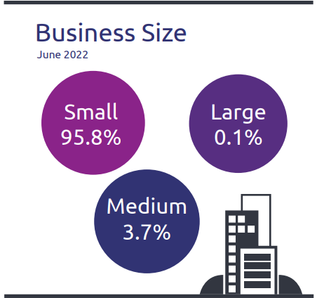

- NT business size:
  - Small is 95.8%
  - Medium is 3.7%
  - Large is 0.1%

Business location
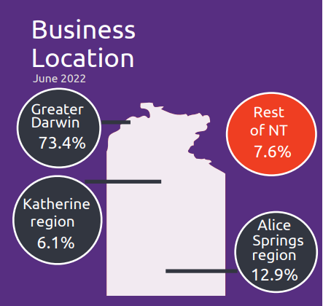

- Businesses by location:
- Greater Darwin has 73.4%
- Katherine has 6.1%
- Alice Springs has 12.9%
- Rest of NT has 7.6%

NT Department of Industry, Tourism and Trade
t: 08 8999 5139
industry.nt.gov.au

