Economic growth
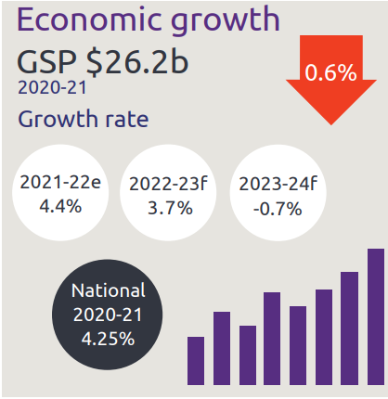
- Economic growth GSP $26.2 billion
- NT growth rate:
  - 2021-22 is 4.4%
  - 2022-23 is 3.7%
  - 2023-24 is -0.7%
- National growth rate in 2020-21 is 4.25%

Industry share of output top 5
- Construction is 5.6%
- Mining is 24.6%
- Public admin is 11.9%
- Health is 8.1%
- Education is 4.9%

Private business investment
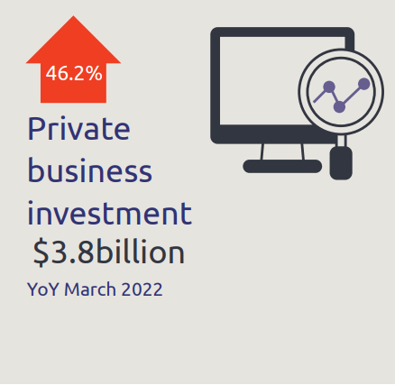
- Private business investment, up 46.2% to $3.8 billion year on year March 2022

Business confidence for the Northern Territory
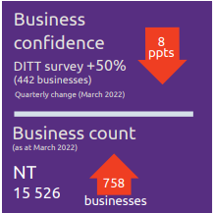

- Business confidence for the Northern Territory is +50% (442 businesses) in the March 2021 quarter, down 8 percentage points from the previous quarter
- Business count as at March 2022 for the Northern Territory was 15,526, up 758 business over the year

Darwin inflation
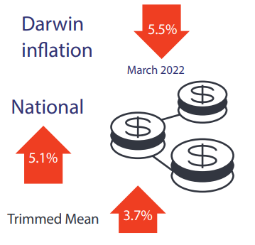
- Darwin inflation decreased 5.5% the year to March 2022
- National inflation increased 5.1%
- Trimmed mean increased 3.7%

Labour market
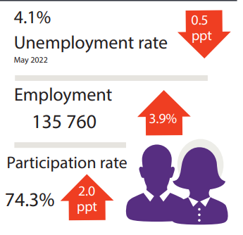
- Unemployment rate is 4.1%
- Employment is 135 760, up 3.9%
- Participation rate was 74.3%, up 2.0 percentage points

NT population
- NT population is 245865, down 0.2% over the year
- National population is 25.7 million, up 0.3% over the year

Population distribution
Population distribution:
- Greater Darwin was 146982
- East Arnhem was 14584
- Katherine was 20893
- Alice Springs was 39458
- Barkly was 6140
- Daly-Tiwi-West Arnhem was 17852

Average weekly earnings
Average weekly earnings in the NT is $1789, up 0.8%, and nationally is $1813, up 2.4%

Median house prices
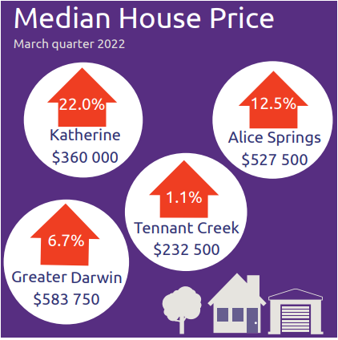
Median house prices in the March quarter 2022:
- Katherine $360,000 up 22.0%
- Alice Springs $527,500 up 12.5%
- Tennant Creek $232,500 up 1.1%
- Greater Darwin $ 583,750 up 6.7%

Business size
NT business size:
- Small is 96.7%
- Medium is 3.2%
- Large is 0.1%

Business location
Businesses by location:
- Greater Darwin has 72.9%
- Katherine has 6.4%
- Alice Springs has 13.1%
- Rest of NT has 7.6%

NT Department of Industry, Tourism and Trade
t: 08 8999 5139
industry.nt.gov.au

