Economic growth
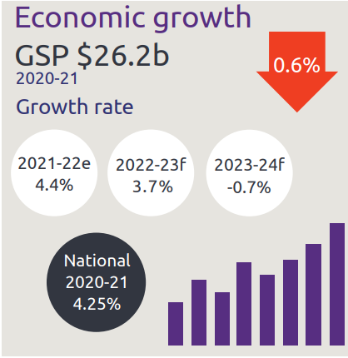
- Economic growth GSP $26.2 billion
- NT growth rate:
  - 2021-22 is 4.4%
  - 2022-23 is 3.7%
  - 2023-24 is -0.7%
- National growth rate in 2020-21 is 4.25%

Industry share of output top 5
- Construction is 5.6%
- Mining is 24.6%
- Public admin is 11.9%
- Health is 8.1%
- Education is 4.9%

State Final Demand
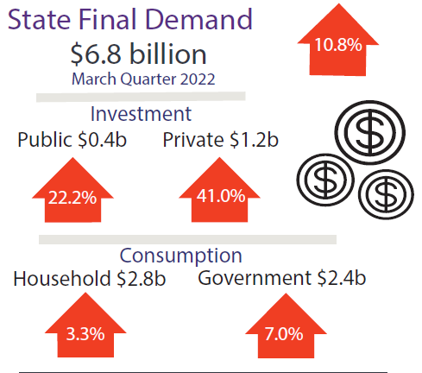
- State Final Demand, up 10.8% to $6.8 billion through the year to March 2022
  - Public investment, up 22.2% to $0.4 billion through the year to March 2022
  - Private business investment, up 41.0% to $1.2 billion through the year to March 2022
  - Household consumption, up 3.3% to $2.8 billion through the year to March 2022
  - Government consumption, up 7% to $2.4 billion through the year to March 2022

Business confidence for the Northern Territory
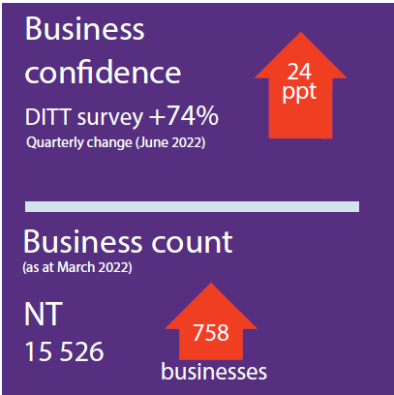

- Business confidence for the Northern Territory is +74% (360 businesses) in the June 2022 quarter, up 24 percentage points from the previous quarter
- Business count as at March 2022 for the Northern Territory was 15,526, up 758 business over the year

Darwin inflation
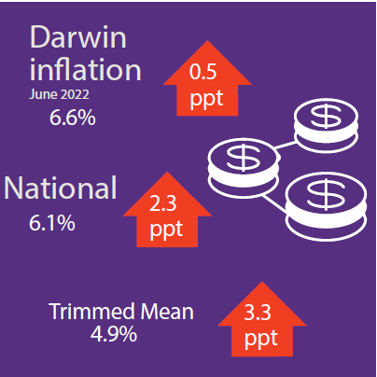
- Darwin inflation decreased 6.6% through the year to June 2022
- National inflation increased 6.1%
- Trimmed mean increased 3.3%

Labour market
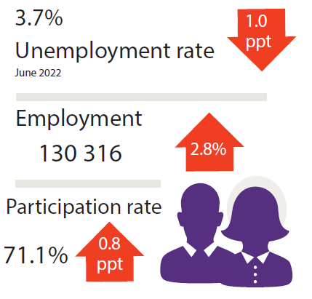
- Unemployment rate is 3.7%
- Employment is 130,316, up 2.8%
- Participation rate was 71.1%, up 0.8 percentage points

NT population
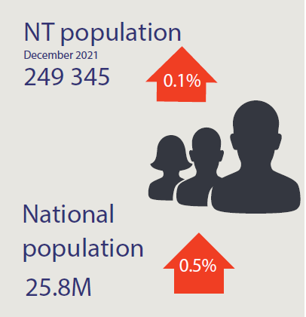
- NT population is 249,345, up 0.1% through the year
- National population is 25.8 million, up 0.5% through the year

Population distribution
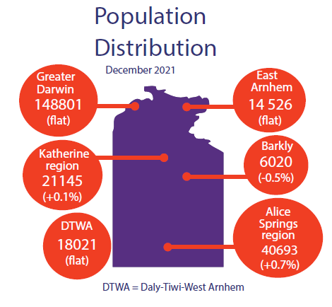
Population distribution:
- Greater Darwin was 148801
- East Arnhem was 14526
- Katherine was 21145
- Alice Springs was 40693
- Barkly was 6020
- Daly-Tiwi-West Arnhem was 18021

Average weekly earnings
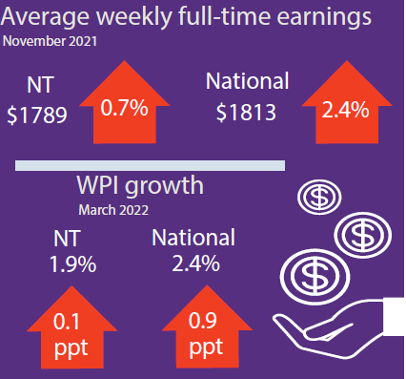
Average weekly earnings in the NT is $1789, up 0.8%, and nationally is $1813, up 2.4%
WPI in the NT increased by 1.9% through the year and 2.4% nationally

Median house prices
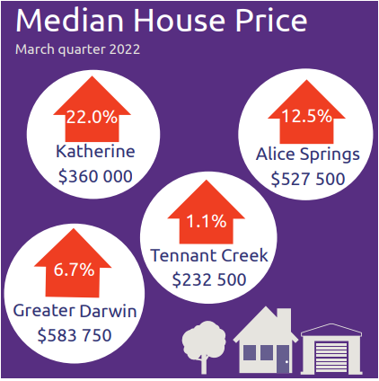
Median house prices in the March quarter 2022:
- Katherine $360,000 up 22.0%
- Alice Springs $527,500 up 12.5%
- Tennant Creek $232,500 up 1.1%
- Greater Darwin $ 583,750 up 6.7%

Business size
NT business size:
- Small is 96.7%
- Medium is 3.2%
- Large is 0.1%

Business location
Businesses by location:
- Greater Darwin has 72.9%
- Katherine has 6.4%
- Alice Springs has 13.1%
- Rest of NT has 7.6%

NT Department of Industry, Tourism and Trade
t: 08 8999 5139
industry.nt.gov.au

