NT Agriculture, Forestry and Fishing Projects
- The NT is an open, trade-oriented economy
- Key exports include LNG, live animals, and mineral ores and concentrates
- Over 80% of NT exports go to Japan, China, Thailand, and Indonesia
- Key imports include iron, steel and aluminium structures, pipes of iron or steel, and refined petroleum
- The NT’s major import partners are from Singapore, Switzerland, and Malaysia
- The Northern Territory has a land mass of 1 348 199 km2, the third largest Australian jurisdiction
- The NT has a small and sparsely distributed population of 245 869, accounting for about 1.0% of the Australian resident population
- The NT civilian population (15+ years) is 187 488 persons, with a labour force of 140 387 persons, including 132 925 people employed
- The NT is characterised by a young population, with a median age of 33 years compared to 37 years nationally
- 30.3% of the resident NT population are Aboriginal or Torres Strait Islander
- More than half of the NT’s population reside in the Greater Darwin region, the main hub of economic activity
- The NT has considerable onshore and offshore energy resources, in addition to existing and prospective mineral, agriculture, aquaculture and horticulture projects.
- The NT’s developing economic infrastructure connects regions and key markets through roads, ports, international airport, gas pipeline and Darwin to Adelaide railway
- Economic output (GSP) in 2018-19 was $26.1 billion, a 1.5% decrease from 2017-18
NT Mining and Energy Projects
• The NT’s five largest industries by output are mining; public administration and safety; health care and social assistance; construction; education and training; comprising a combined 48% of total NT GSP
• The Defence presence (air force, army, and navy) in the region plays a significant role
• Tourism activity is an expanding sector with significant tourism economy and assets such as the world-famous Kakadu National Park, Uluru, Katherine Gorge; and other national parks

Introduction
The Territory’s economy, while relatively small compared to other Australian jurisdictions, is vibrant and has an abundance of mineral and energy resources. Its close proximity to Asia, the fastest growing region of the global economy, and a renewed focus of developing northern Australia, provide many potential business opportunities for Territory businesses.

Gross state product (GSP)
The NT’s 10-year average annual economic (GSP) growth rate (2008-09 to 2018-19) was 2.5%. In 2018-19, NT GSP (inflation adjusted) decreased by 1.5% to $26.1 billion, driven by a fall in business investment, and consumption, but partly offset by rising exports (Chart 1). In 2018-19, total investment in the NT was valued at $5.6 billion, a decrease of 44.8% compared to 2017-18.
Private investment is the largest component of total investment, about 71% ($4.0 billion). Private investment decreased by 53.5% over 2018-19 (Chart 2). This decrease was largely driven by a 71.1% fall in non-dwelling construction activities (business investment). In the NT economy, large projects have a considerable impact on investment and generate high levels of economic growth, but also large fluctuations in investment.
Nationally, Gross Domestic Product (GDP) increased by 1.9% in 2018-19. NT GSP accounts for 1.4% of Australian GDP.
Chart 1: State and Territory Real GSP 2018-19
SA - $108B
Source: ABS Cat. No. 5220.0

Chart 2: GSP vs SFD Growth
Source: ABS Cat. No. 5220.0, DTF

Private business investment ($3.2 billion), the key driver of investment ($5.6 billion), comprised about 82% of the total private investment ($4.0 billion) and 58% of the total investment in 2018-19.
NT economic growth is estimated to increase by 6.3% in 2019-20 and further grow by 4.1% in 2020-21 (NT Mid-Year Report 2019-20). This is largely due to a significant increase in LNG exports during the export and operational phase of the Ichthys LNG plant, following the construction phase. Deloitte Access Economics forecasts the NT economy to grow by 4.1% in 2019-20 and by 3.3% in 2020-21. National GDP is estimated to grow by 2.25% in 2019-20 (Australian Mid-Year Economic and Fiscal Outlook 2019-20).
NT State Final Demand (SFD), total domestic expenditure within the local economy, was $24.2 billion (trend and inflation adjusted) in the year to September 2019. For the same period in the previous year SFD was $28.0 billion. Consumption (public and private consumption), the largest component of SFD, comprised 78.5% of domestic demand.
SFD is expected to continue to decline by 1.7% in 2019-20 before slowly improving to 2.2% growth in the outer years of the foreword estimates (Chart 3). The continued weakness is due to moderating private sector investment. The export led growth in GSP in 2019-20 is masking challenging conditions within the local economy

Chart 3: NT Investment, inflation adjusted
Source: ABS Cat. No. 5220.0, DTF

NT SFD component | Proportion of SFD in the year to September 2019
 | Sept 2019 | Sept 2018 | Annual change
Private consumption | 44.9% | 39.6% | Increase
Public consumption | 33.6% | 28.9% | Increase
Private investment | 14.8% | 25.4% | Decrease
Public investment | 6.7% | 6.1% | Increase

International trade
In 2019, the value of NT goods exported rose to $11.9 billion. This represents a 73.0% increase on the same time last year which can be attributed to the commencement of LNG exports from the INPEX project (Chart 4).
The value of goods imported has dropped 9.9% to $1.7 billion when compared to the same time last year.
The NT’s trade surplus sits at $10.2 billion in 2019 which represents the highest level on record.
The NT contributed about 3.0% of Australia’s goods exports, and around 0.5% of imports in 2019.
A significant proportion of imports to the NT come from other Australian jurisdictions and is treated as the balancing item in the GSP accounts.

Chart 4: NT International Trade
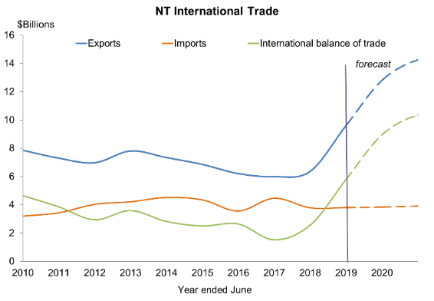
Source: ABS Cat. No. 5368.0

Major NT imports from overseas are petroleum, transport equipment, and road vehicles.
The NT’s major exports to overseas are LNG, live animals, and mineral ores and concentrates.
The majority of NT exports are destined for North and South East Asia (Japan and China are key export partners) while the main import partners in 2019 were Singapore, Switzerland, and Malaysia.

Population
As at June 2019, the NT’s resident population was 245 869, a decrease of 0.5 percent in annual terms (Chart 5). Natural increase and net overseas migration added to the population while net interstate migration detracted from population growth. NT population has moderated over the past year, and is forecast to remain steady in 2019 before beginning to increase again in 2020 at 0.6% (NT Mid-Year Report 2019-20).
The population of Australia in June 2019 was 25 364 307 people. The NT population comprised 1.0% of the national population.
The estimated resident Aboriginal and Torres Strait Islander population of the NT in June 2016 was 74 509 persons, comprising around 30.3% of the NT resident population. Around 49.9% of the Indigenous population were females. Nationally, the Indigenous population accounts for 3.3% of the total population.
The NT population is relatively young (median age of 33 years compared to 37 years nationally) with a higher male-to-female sex ratio 107.5 males per 100 females compared to 97.4 males per 100 females nationally.
Chart 5: Northern Territory Population
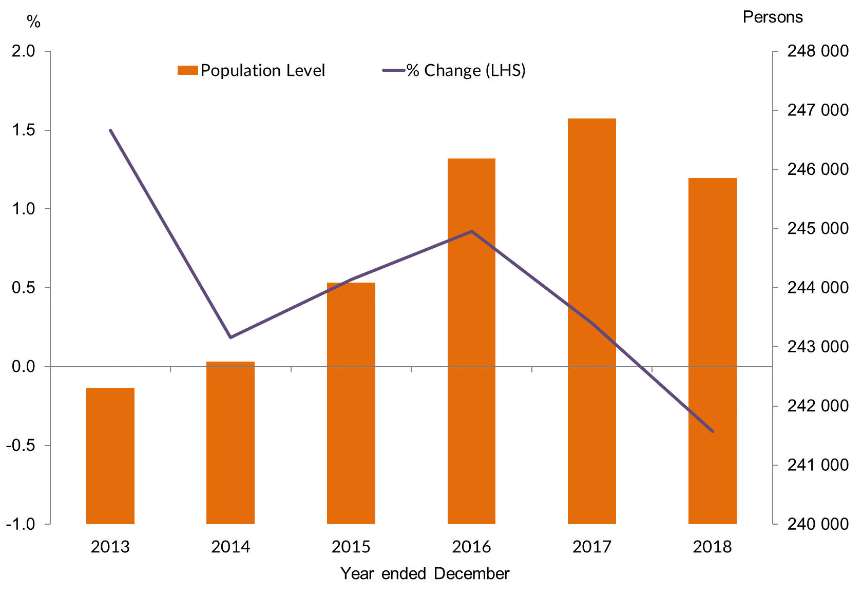
Source: ABS Cat. No. 3101.0
Chart 6: NT Age Distribution 2018

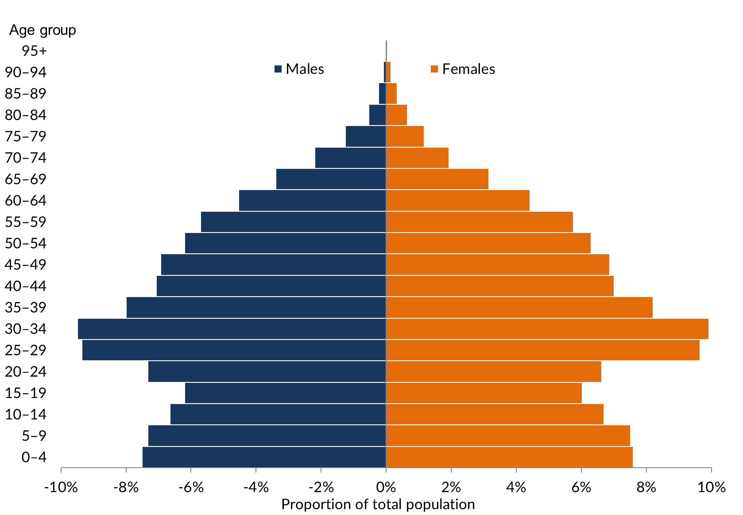
Source: ABS Cat. No. 3101.0
Chart 7: NT Regional Population, June 2018
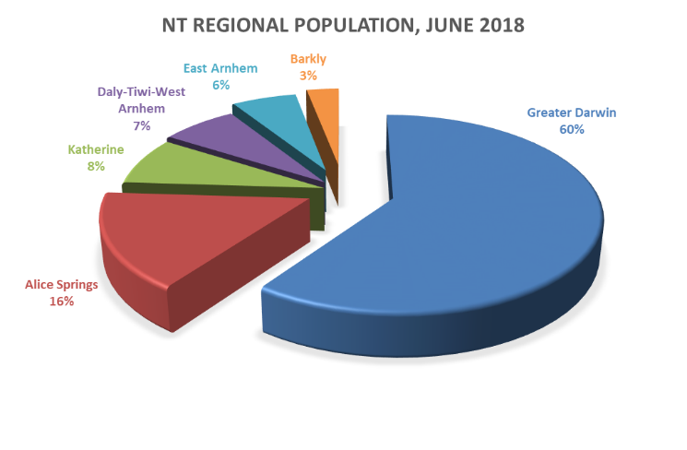
Source: ABS Cat. No. 3218.0
In the December quarter 2019, the civilian population (15+ years) of the NT was 187 815 persons, about 76.3% of the total population. Nationally, the civilian population was 81.6% of the population.
Around 60.1% of the NT population is located in the Greater Darwin area (Darwin City, Darwin suburbs, Litchfield and Palmerston) with Central Australia (Alice Springs region) accounting for a further 15.9% and the Katherine region accounting for 8.4% of the total population (Chart 7).

Labour market
The NT labour market is characterised by a relatively skilled labour force with a high level of labour participation. There are however, regional differences in the labour market characteristics.
In December 2019, the NT unemployment rate remained steady at 5.3% (trend) but has increased by 0.6 percentage points over the year (Chart 8), and is the fourth lowest unemployment rate of all Australian jurisdictions. Nationally, the unemployment rate was 5.2%.
Employment levels have increased for eight consecutive months with 132 925 persons employed across the NT at December 2019. This represents a 0.3% increase when compared to December 2018. The year on year change in resident employment declined by 4.2%, while national employment levels increased by 2.4% over the same period (Chart 9).
Regional statistics show the unemployment rate increased in the Daly-Tiwi-West Arnhem, Katherine and East Arnhem regions, while falling in Alice Springs, and Barkly, and remaining unchanged in Greater Darwin.
Chart 8: NT Participation and Unemployment Rate
Source: ABS Cat. No. 6202.0

Chart 9: NT Total Employed and Growth Rate
Source: ABS Cat. No. 6202.0

As at December 2019, of the civilian population of 187 488, 74.9% (140 387) are in the labour force, of which 132 925 were employed.
The NT underemployment rate was the lowest of all jurisdictions at 5.5% of total employed persons in December 2019, compared to 8.5% nationally. This signifies that there are more employed people in the NT working their desired number of hours.
The NT underemployment rate has been trending down over the past six months.
The NT underutilisation rate (unemployment rate+ underemployment rate) was 10.8% of the total employed persons in December 2019. This rate has trended down over the past six months from 11.1 in August 2019.
The NT participation rate has been trending upwards over the past eight months and still remains highest of all jurisdictions at 74.8% (Chart 8). This represents a 1.0 percentage point increase in annual terms. The national participation rate is 66.0% in the same period.
Non-resident labour (including fly-in-fly-out workers) is an important component of the NT labour market statistics. Although difficult to measure, Census 2016 estimated it to be about 8700 workers in June 2016. Similarly, members of the Australian Defence Force are also not included in the labour force statistics, but Australian Defence Force data estimated it to be about 4397 permanent defence force personnel as at June 2018 (Department of Treasury and Finance).
Employment levels in the NT are forecast to fall by 2.0% in 2019-20 (NT Mid-Year Report 2019-20) before recovering to 0.7% growth in 2020-21 and 0.9% growth in 2021-22.
Chart 10: NT Total Employment by Industry, November 2019
Source: ABS Cat. No. 6291.0.55.003

As at December 2019 the number of youth employed (aged 15-24 years) in the NT decreased to 16 700, which represents a 6.1% year on year decline. At the national level, youth employment increased to 1 958 300 persons, representing a 1.4% year on year increase.
NT employment by industry sector data (annual moving average at November 2019) shows that Public administration and safety is the largest employer employing about 15.7% of the total employed, ahead of Health care and social assistance (15.0%).
Other large industry employers include, Education and training (9.1%), Retail trade (8.8%), and Construction (7.8%). The Mining industry on the other hand employs around 1.9% of the NT workforce (Chart 10).
In the year to December 2019, there were 2348 apprentice and trainee commencements in the Territory, a decrease of 1.8% compared to the same period in the previous year. Over the same period there were 1070 apprentice and trainee completions, an increase of 1.0% compared to the same time last year.

Prices
The consumer price index (CPI) increased by 0.2% in the December quarter 2019 (Chart 11).
Over the year to December 2019, the Darwin CPI increased by 0.5% to 111.5. Over the year, the categories with the largest increases were Tobacco and alcohol (up by 6.5%).
Communication was the only category to report a decrease over the year (down by 3.8%). Darwin’s CPI is lower than the national average of 1.8%.
Chart 11: Inflation Aggregates, Annual data
Source: ABS Cat. No. 6401.0

Chart 12: Darwin CPI Components, December Qtr 2019
Source: ABS Cat. No. 6401.0
The Reserve Bank of Australia’s (RBA) measure of the national annual underlying inflation (core inflation) increased by 1.6% in the December Quarter 2019, lower than the RBA’s target inflation range of 2-3%.

Residential property prices
In the NT property market, sales have moderated, with lower home purchase prices and lower rents.
The December Quarter 2019 Real Estate Institute of the NT’s (REINT) data on median prices for a 3 bedroom house ranged from $150 000 in Tennant Creek to $725 000 in Inner Darwin (Chart 13). Median 2 bedroom residential unit prices ranged from $155 000 in Katherine to $440 000 in Darwin North East.
REINT reported the median rent price for a 3 bedroom house ranged from $400 in Palmerston to $550 in Inner Darwin. Median 2 bedroom residential unit rents ranged from $300 in Darwin North to $400 in Inner Darwin and Alice Springs (Chart 14).
Location | Median House price | Median Unit/ Townhouse price
Darwin Overall | $460 065 | $306 000
Inner Darwin | $725 000 | $335 000
Palmerston | $430 000 | $239 000
Katherine | $297 500 | $155 000
Tennant Creek | $150 000 | N/A
Alice Springs | $450 000 | $304 500
The property price index (PPI - established house price and attached house price) produced by ABS for Australian capital cities, show that for the September Quarter 2019, Darwin PPI decreased by 1.2%, while nationally the PPI increased by 2.4%.
Chart 13: House and Unit Purchase Price, December Qtr
Source: REINT

Chart 14: House and Unit Rental Price, December Qtr
Source: REINT

Income
The average weekly earnings and wage price index measure are different but related concepts. Average weekly earnings captures the current average value of wages and salaries paid to employees. Wage price index measures changes in wages and salaries paid by employees for a unit of labour where the quality and quantity of labour are not considered. The Wage Price Index is designed to measure inflationary pressures on wages and salaries.
Average weekly earnings have generally increased over time, however, the rate of growth has fluctuated.
In annual terms the average weekly full time adult earnings (AWFTE) in the NT increased by 0.7% in the six month period to November 2019 to $1778, compared to the national weekly earnings of $1721 (Chart 15). The NT has the third highest AWFTE among Australian jurisdictions, behind WA ($1860) and ACT ($1854).
Over the year, the AWFTE for males in the NT was unchanged at $1911 and for females it increased by 3.6% to $1614. A substantial difference between male and female wage levels exists - both in the NT and at the national level.
In annual terms to December 2019, the WPI increased by 2.5% in the NT. Nationally, the growth in the WPI was 2.2% in the same period (Chart 16).
Chart 15: Average Weekly Earnings
Source: ABS Cat. No. 6302

Chart 16: Wage Price Index, all sectors
Source: ABS Cat. No. 6345.0

Business confidence
The Department of Trade, Business and Innovation (DTBI) conducts its own quarterly business confidence survey with a significantly higher sample size than the Sensis® Business Index (SBI), and includes results by region and industry.
In the December 2019 DTBI quarterly survey, business confidence was +52%, with confidence by region ranging from +89% in East Arnhem to +11% in Daly-Tiwi-West Arnhem. Over the past year, business confidence has been gradually trending upwards (Chart 17).
Overall 46% of businesses report business performance is better this year compared to the previous year. Over the past year, the proportion of businesses reporting better business conditions has been trending upwards, while the proportion of businesses reporting worse business conditions has been trending downwards (Chart 18).
In the December quarter 2019, key reasons for businesses feeling confident include strong customer relations, strong market position, and been in business a long time. Key reasons why businesses were worried included lack of suitably skilled workers, decrease in business/sales, and a weak local economy.
Note: The SBI does not adequately assess the business confidence levels in the Territory due to a small and unrepresentative sample size (8 survey responses for over 14 000 businesses in the November quarter 2019). In 2019, SBI incorporated changes to its survey methodology, largely reflecting the transition to online surveys from telephone-based interviews, and publication design. Sensis noted that the methodology change would result in a quicker turnaround time, however it is unknown when the next SBI publication is expected to be released.
Chart 17: NT Business Confidence
Source: DTBI Business Confidence Survey

Chart 18: NT Business Performance
Source: DTBI Business Confidence Survey

Count of NT businesses
The NT had 14 479 actively trading businesses as at June 2018 which constitutes 0.63% of the national business count. In June 2017 there were 14 442 businesses operating (Chart 19).
The highest number of operating businesses was in New South Wales followed by Victoria, Queensland, Western Australia, South Australia, Tasmania, the Australian Capital Territory and the NT.
In 2017-18 the entry rate for businesses in the NT was 13.5%, lower than the national average of 15.8%. The exit rate for businesses in the NT was 12.5%, lower than the entry rate and resulting in an increase in the number of overall businesses. Nationally, the exit rate was 12.5%.
In June 2014, the NT had 14 277 operating businesses and of these 86.7% survived to June 2015, 76.6% survived to June 2016, and 69.3% survived to June 2017 and 62.9% survived to June 2018. Similarly, at the national level, 64.5% of the businesses operating in June 2014 survived to June 2018.
Australian Bureau of Statistics (ABS) defines business size by level of employment as follows:
- Small business: 0-19 employees
- Medium business: 20-199 employees
- Large business: 200+ employees.
The majority of actively trading businesses in the NT are small. In June 2018, 95.8% were small businesses, 4.0% were medium businesses and 0.2% were large businesses (Chart 20). Nationally, 97.6% of the businesses were small.
Chart 19: Number and Growth of NT Businesses
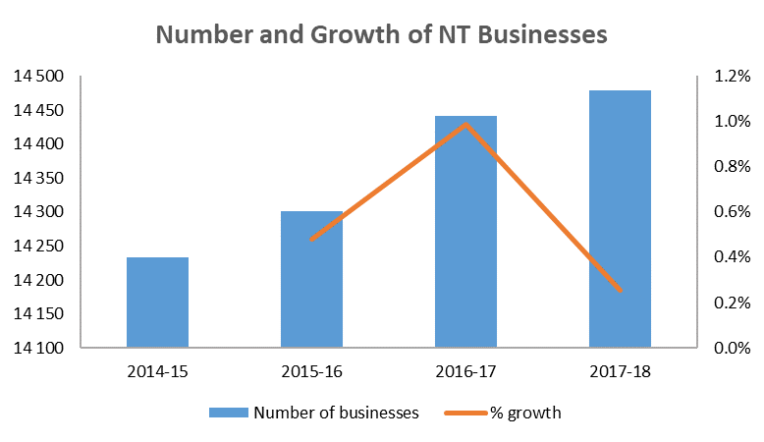
Source: ABS Cat. No. 8165.0

Chart 20: NT Business size, June 2018
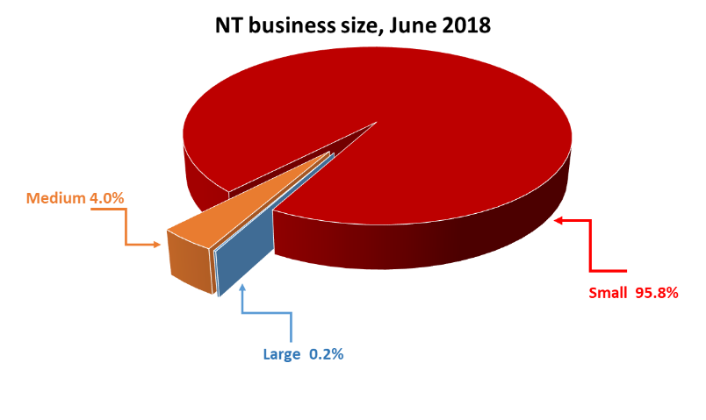
Source: ABS Cat. No. 8165.0
Of the small businesses in the NT, 60.9% were non-employing businesses, 25.7% were micro businesses with between 1-4 employees, and 13.4% were those businesses employing 5-19 employees.
In June 2018, the Construction industry had the highest number of businesses operating in the NT accounting for 20.1% of total businesses. This was followed by Rental, hiring and real estate services (13.2%), Professional, scientific and technical services (9.3%), Transport, postal and warehousing (6.8%), Finance and insurance services (6.4%), and Agriculture forestry and fishing (6.3%) (Chart 21).
The majority of businesses in the NT are in the services sector (all industries except Agriculture, forestry and fishing; Mining; Manufacturing; Electricity, gas and water; and Construction).
In June 2018, the services sector included 69.5% of all NT businesses.
At the national level, the Construction industry had the highest number of businesses (16.6%) followed by Professional, scientific and technical services (12.1%) and Rental, hiring and real estate services (10.9%).
The majority of the businesses in the NT are located in the Greater Darwin region (Darwin City, Darwin Suburbs, Litchfield and Palmerston).
In June 2018, 72.7% of all businesses in the NT were located in the Greater Darwin region. The Alice Springs region had the second largest number of businesses (14.2%), Katherine region had 6.3%, Daly-Tiwi-West Arnhem had 2.5%, East Arnhem had 1.5% and Barkly region had 1.5% (Chart 22).
Chart 21: NT Business by Industry, June 2018
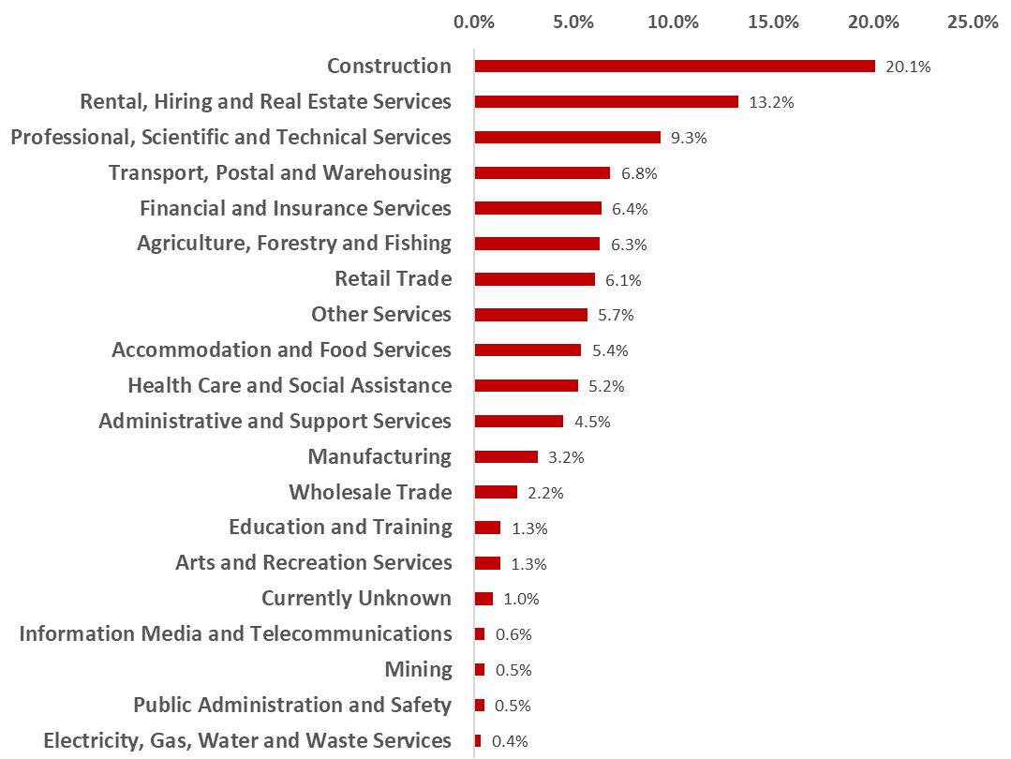

Source: ABS Cat. No. 8165.0

Chart 22: Business Location, June 2018
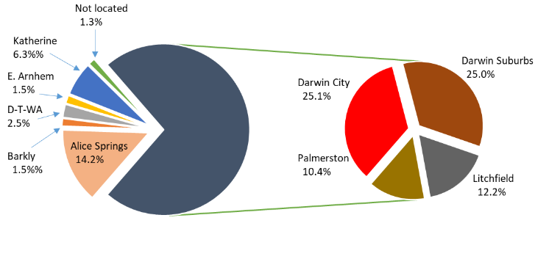
Source: ABS Cat. No. 8165.0

At June 2018, the NT had 21.3% of businesses operating in the ‘zero to <$50k’ turnover range. About 13.2% of the businesses were operating in the ‘$50k to < $100k’ range, 17.8% in the ‘$100k to <$200k’ range, 20.1% were in the ‘$200k to <$500k’ range, 18.1% in the ‘$500k to <$2m’ range, and 6.0% in the ‘$2m to <$5m range, 2.1% in the $5m to <$10m range, and 1.4% in the $10m+ range.

Key industry sectors
The structure of the NT economy is different to the national economy with greater contributions to production in the NT from Construction, Mining, Public administration and safety, Education and training, and Health care and social assistance industries.
These five sectors together make up 48.1% of the total of industry sector contributions to the NT’s GSP in 2018-19 with the combined value of their contribution to the NT economy being about $12.6 billion.
Industry sector | Value Added 2018-19 | Proportion of NT GSP
Mining | $4.7 billion | 18.1%
Public Administration and Safety | $3.3 billion | 12.5%
Heath Care & Social Assistance | $1.7 billion | 6.6%
Construction | $1.6 billion | 6.2%
Education and training | $1.2 billion | 4.7%

Chart 23: Sector Contribution to Output, NT and Australia 2018-19
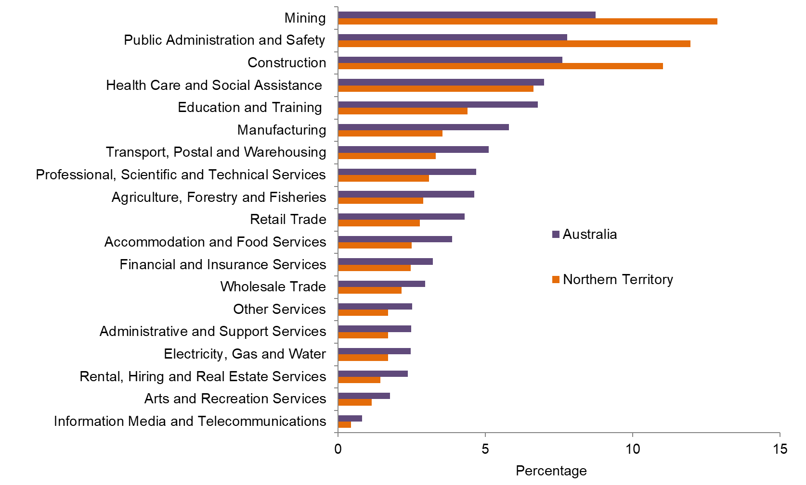
Source: ABS; Cat. No. 5220.0

Construction sector
In 2018-19, the Construction sector contributed $1.6 billion to NT GSP, with an industry share of total output of 6.2%. The construction industry accounts for 7.8% of the NT’s resident employment.
The value of the Construction sector is now below historical levels largely due to the completion of major construction projects such as INPEX LNG gas project.
In 2019, construction work done decreased by 56.7% to $2.1 billion. Engineering work done decreased by 65.2% to $1.3 billion, residential construction decreased by 23.4% to $324 million and non-residential construction decreased by 27.3% to $440 million, reflecting construction of the INPEX LNG plant winding down (Chart 24).
Over the next few years, growth is forecast to remain subdued with the completion of the construction phase of some resource projects.

Mining and energy sector
Mining and energy sector contributed $4.7 billion (gross value-added) or 18.1% to NT GVA in 2018-19 (Chart 26).
The main minerals produced and processed in the NT are bauxite, gold, manganese and zinc/lead concentrate. Key energy commodities are oil, natural gas, uranium, and the production of LNG.
Although the sector is the largest contributor to NT GSP it employs around 1.9% of the resident employment as it is capital intensive and a portion of its FIFO workers are residents of other jurisdictions.
Chart 24: NT Construction Activity
Source: ABS Cat. No. 8755.0
Chart 25: Construction, GVA, Inflation Adjusted
Source: ABS Cat. No. 5220.0

Chart 26: Mining, GVA, Inflation Adjusted
Source: ABS Cat. No. 5220.0
The value of Mining and energy increased strongly in 2018-19 as LNG production commenced at INPEX’s LNG plant.

Manufacturing sector
In 2018-19, the Manufacturing sector accounted for 3.6% of the NT’s GSP (Chart 27).
Manufacturing in the NT consists mainly of small scale production of various products for export and domestic consumption, and mining-related processing.
This sector employs around 3600 people, 2.8% of the NT’s total resident employment in the year to November 2019.

Retail sector
The Retail trade sector value (gross value added) decreased by 2.1% in 2018-19 to $691 million. The sector contributes around 2.6% to NT GSP and 8.8% to total NT resident employment in the year to November 2019 (Chart 28).
Nationally, retail turnover in 2018-19 contributed about 4.2% of the national GDP and the sector grew by 1.0% in the same period.
The retail turnover (sales) in the NT in 2019 was $3.1 billion, a year on year decline of 0.9%.
Food retailing is the largest component contributing 49.4% of total retail trade turnover in the NT in the year, followed by Cafés, restaurants and takeaway food services (14.6%), Household goods retailing (14.4%), and Clothing, footwear and personal accessories (5.3%).

Chart 27: Manufacturing, GVA, Inflation Adjusted
Source: ABS Cat. No. 5220.0

Chart 28: Retail trade, GVA, inflation adjusted
Source: ABS Cat. No. 5220.0

The growth in NT retail turnover is expected to be subdued in the short term, largely reflecting softening population growth in the NT.
The Wholesale trade sector contributed $524 million or about 2.0% of the NT GSP.

Agriculture, forestry and fishing (rural industries)
Key agricultural commodities include livestock, horticulture produce and fisheries.
The key livestock commodities of the NT include cattle, buffaloes and crocodiles. In the horticultural sector the main commodities include fruit (mangos, melons, and bananas), Asian vegetables, and plant nursery products. The fishing sector includes commercial, recreational and traditional indigenous fishing. The commercial fishing sector includes wild catch fish (such as barramundi, snapper, and shark), crustaceans (mainly prawns and mud crabs) and aquaculture (pearls). Forestry includes sandalwood and African Mahogany production.
Agriculture, fishing and forestry contributed $700 million (inflation adjusted), about 2.7% to the value of NT GSP in 2018-19 (Chart 29).
Cattle production is the largest component of agriculture, forestry and fishing. The key markets for NT cattle are interstate markets (for further growing or slaughter) and live exports overseas (mainly Indonesia). In the short term, the value of this industry is expected to increase, driven by growth in the value of live cattle exports under the free trade agreement signed in March 2019 between Australia and Indonesia. This will be partly offset by competition from Indian
Chart 29: Agriculture, Forestry and Fishing: NT GVA, Inflation Adjusted
Source: ABS Cat. No. 5220.0
buffalo meat and disruptions in the cattle supply chain from severe Queensland floods.
Horticultural production is expected to improve with favourable outlooks for barramundi and prawn production, and recovering production of bananas and melons. The horticultural products are mainly destined for interstate markets.
Fisheries production in the NT has strong potential in the coming years with the expansion of aquaculture production, e.g. Seafarms’ $1.45 billion Sea Dragon Project.

Tourism
The Tourism sector is distributed across a number of Australian and New Zealand Standard Industrial Classification (ANZSIC) industry sectors. The largest industry sectors that directly contribute to tourism gross value added (GVA) in the NT include Accommodation and food services; Transport, postal and warehousing, and Recreation and culture.
In the year to September 2019, visitor expenditure in the NT was $2.6 billion (Tourism NT).
Over the same period 1.95 million people visited the NT, up 6.7% on the previous year’s visitor numbers.
Tourism directly employs around 7.1% of the NT employment.

Goods-producing and service-producing sectors
In categorising goods and services, dwelling growth is excluded.

Chart 30: Share of Tourism in Gross Value Added, 2016-17
Source: Tourism Research Australia, 2016-17
The GVA of goods-producing sectors (Agriculture, forestry and fishing, Mining, Manufacturing, Electricity, gas and water, Construction) was $8.4 billion in 2018 19, about 40.7% of all industries.
Service producing sectors’ output (“things you cannot drop on your foot”) was valued at $12.3 billion, contributing 59.3% of all industries NT GSP (ownership of dwellings is excluded from the service-producing sectors).
Business services (those industries that provide non distribution services to other companies) have grown strongly since 2011 and contributed $2.7 billion (10.3%) of NT GSP in 2018-19. Since 2011 business services have grown, on average, by 5.2%. There are however, variations in growth in individual business service sectors (Chart 31).
Chart 31: Business Services Output
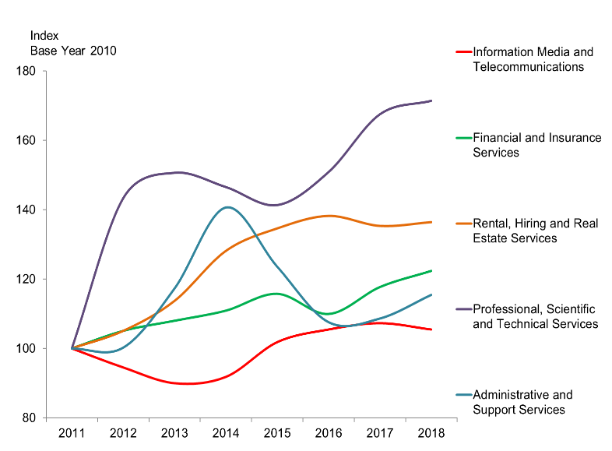
Source: ABS Cat. No. 5220.0

Investment projects – major project status
Project | Company | Location | Type | Under construction | FID | Resource | Indicative cost estimate
Northcrest | Halikos | Darwin | New project | Yes | Yes | Land development | $300 million
SASH | Sun Cable | Tennant Creek | New Project | No | No | Solar PV, Storage and Export | $19 billion
TNG – Metals Processing | TNG Limited | Darwin – East Arm | New project | No | To be announced | Metals Processing - Producing 3 Products Titanium Dioxide; Vanadium Pentoxide and Pig Iron | To be confirmed (Stage 1)
Mount Peake | TNG Limited | 235 kilometres northwest of Alice Springs | New project | No | To be announced | Production of magnetite concentrate | $207 million (Stage 1)
Nolans Project | Arafura Resources | 135 kilometres north northwest of Alice Springs | New project | No | 2018-19 | Rare earths and phosphoric acid | $850 million
Mount Todd | Vista Gold | 56 kilometres northwest of Katherine | Redevelopment | No | 2018-19 | Gold | $1 billion
Ammaroo Phosphate | Verdant Minerals | 180km South East of Tennant Creek | New project | No | TBA | Phosphate | To be confirmed
Jervois Base Metals Project | KGL Resources | 270km east north east of Alice Springs | New project | No | 2018-19 | Copper/lead and zinc | $216 million
Shell Prelude FLNG | Shell | Browse Basin |  | Complete | Yes | LNG | $12 billion or more
Wonarah | Avenira Limited | 260 kilometres east of Tennant Creek | New project | No | To be announced | Superphosphoric acid | To be announced
Chandler Salt Mine | Tellus Holdings | Alice Springs | New project | No | To be announced | Salt (Out)
Waste/Record (In) | $676 million
Project Sea Dragon | Seafarms Group | Gunn Point | New project | No | To be announced | Prawns larvae for Legune
Project Sea Dragon | Seafarms Group | Bynoe | New project | Yes | 2018-19 | Broodstock for Gunn Point | $2.1 billion (all sites)
Source: Bureau of Resources and Energy Economics (BREE), NT ICN and NT Department of Trade, Business and Innovation

Future major projects – major project status
Project | Company | Location | Type | Under construction | FID | Resource | Indicative cost estimate
Bonaparte Gas Project | Neptune | Petrel/Tern/Frigate Gas Field (Offshore) | New project | No | No | LNG | To be announced
Bladin Point LNG Expansion (Trains 3-6) | INPEX Holdings | Bladin Point | Expansion | No | No | LNG | To be announced
Source: Bureau of Resources and Energy Economics (BREE), NT ICN and NT Department of Trade, Business and Innovation

Investment projects – facilitated investment projects
Project | Company | Location | Type | Under construction | FID | Resource | Indicative cost estimate
Ichthys LNG | Inpex Holdings/ Total | Darwin | New project | Operational | Yes | LNG | $34 billion
Westin Hotel | Landbridge | Darwin | New project | Yes | Yes | Other – hotel | $200 million
Northern Gas Pipeline | Jemena | Tennant Creek – Mount Isa | New project | Complete | Yes | Gas pipeline | $800 million
Darwin Shiplift | PMA | Darwin | New project | No | No | Infrastructure | $100 million or more
Seniors Lifestyle Accommodation | TBD | Darwin rural | New project | No | No | Other | To be announced
Seniors Lifestyle Accommodation | TBD | Darwin | New project | No | No | Other | To be announced
Seniors Lifestyle Accommodation | TBD | Alice Springs | New project | No | No | Other | To be announced

Future projects – facilitated investment projects
Project | Company | Location | Type | Under construction | FID | Resource | Indicative cost estimate
Mount Isa – Tennant Creek Railway | To be announced | Mount Isa – Tennant Creek | New project | No | No | Infrastructure | $3 billion - $4 billion
Ord Stage 3 | To be announced | WA-NT border | Expansion | No | No | Infrastructure | To be announced
Alice Springs Tourism Commercial | To be announced | Alice Springs | New project | No | No | Other | To be announced

Regional labour markets, population and income
Region¹ | Labour force  September Qtr 2019 | Unemployment  September Qtr 2019 | Unemployment rate (%)  September Qtr 2019 | Population  2017-18 | Median weekly household income 2016 ($)¹
Greater Darwin | 111 899 | 5 803 | 5.2 | 148,564 | 2,1832
Darwin city | 28 778 | 1 255 | 4.2 | 28,420 | 2,320
Darwin suburbs | 56 462 | 3 293 | 6.7 | 57,083 | 2,075
Litchfield | 9 469 | 420 | 4.7 | 25,220 | 2,219
Palmerston | 17 190 | 835 | 5.0 | 37,841 | 2,199
Alice Springs | 16 230 | 985 | 6.2 | 39,388 | 1,715
Barkly | 5 440 | 290 | 5.6 | 6,155 | 1,366
Daly-Tiwi-West Arnhem | 10 913 | 786 | 7.6 | 17,902 | 1,134
East Arnhem | 6 101 | 312 | 5.3 | 14,519 | 1,944
Katherine | 13 844 | 1 078 | 7.2 | 20,839 | 1,485
Source: ABS Cat. No. 3218.0, 5673.0.55.003, Department of Employment, and Census 2016 on Population and Housing
1. Statistical Area Level 3 (SA3)
2. Greater Capital City Statistical Area (GCCSA)

Data sources
Australian Bureau of Statistics, catalogue numbers 3101.0, 6202.0, 6220.0, 6291.0.55.003, 6302.0, 6345.0, 6354.0
Department of Social Services (Australian Government)
Department of Trade, Business and Innovation – Business Confidence Survey

Enquiries
Strategic Policy and Research, Department of Trade, Business and Innovation
Email: SPAR.DTBI@nt.gov.au

Disclaimer
The Northern Territory of Australia gives no warranty of assurance, and makes no representation as to the accuracy of any information or advice contained in this publication, or that it is suitable for your intended use. You should not rely upon information in this publication for the purpose of making any serious business or investment decisions without obtaining independent, professional advice in relation to your particular situation.

