Key points
- Territory-wide business confidence was positive at +55%, in the June quarter 2024. This was up from +54% in the March quarter 2024 and from +44% in the June quarter 2023.
- Commonly cited reasons for confidence in the quarter were ‘strong customer relations’, ‘been in business a long time’ and ‘business opportunity’.
- The most commonly cited reasons for concern were ‘lack of suitably skilled workers’, ‘increasing business costs’ and ‘security & anti-social behaviour’.

Business confidence up slightly in the quarter…
Territory-wide business confidence was positive at +55% for the June quarter 2024, in response to the question ‘How confident are you about your business prospects over the next 12 months?’
The number of confident businesses was unchanged, while worried businesses fell by 2 percentage points (ppt), leading to a marginal improvement of 1 ppt for overall confidence (Table 1).
Table 1: Business confidence index
 | Jun qtr 2024 | Quarterly change | Annual change*
Confident | 67% | 0ppt |  | +10ppt
Worried | 13% | -2ppt |  | -1ppt
Net Balance | 55% | +1ppt |  | +11ppt
*Current quarter compared with the same quarter in the previous year.

Figure 1: Responses to the business confidence question & change from previous quarter
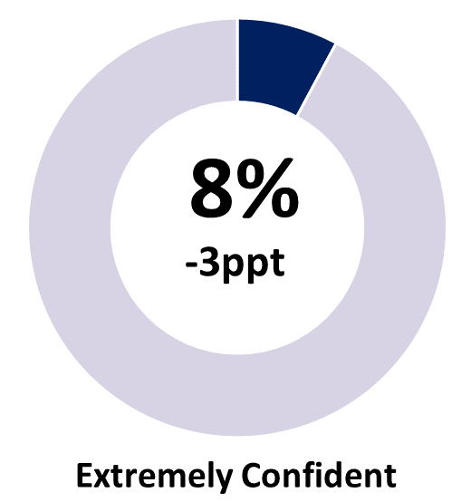 | 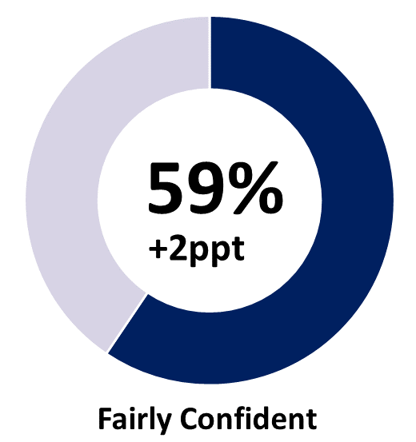 | 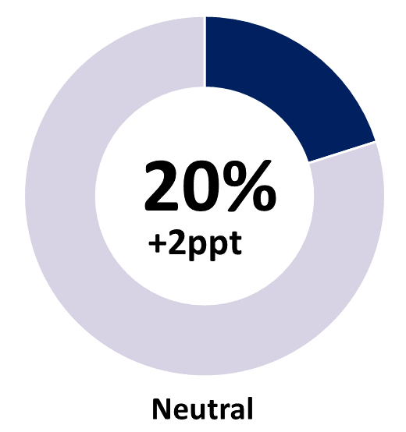
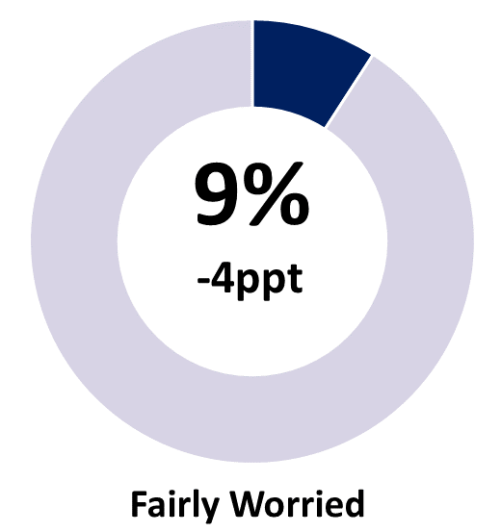 | 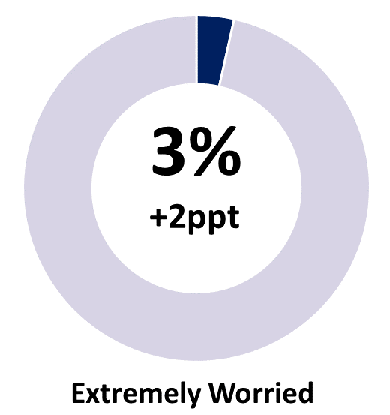 | 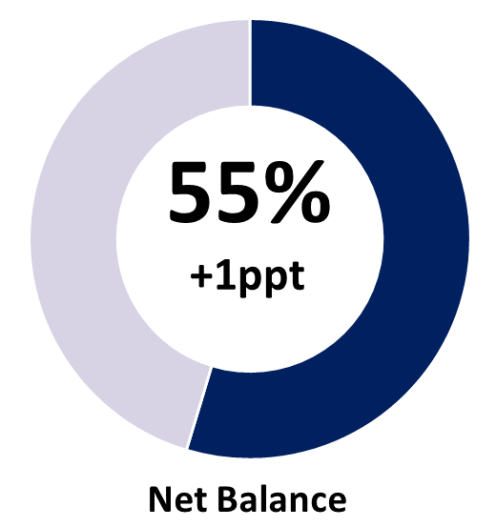
Note: Individual categories may not add to the net balance figure due to rounding.

…and improved over the year
Business confidence increased by 11 ppt compared to the June quarter 2023, as the proportion of confident businesses increased by 10 ppt and worried businesses fell by 1 ppt (Chart 1). The improvement over the year are in the areas of customer relations, been in business for long time, business opportunity, strong market position and favourable business environment.
Average business confidence across 2023-24 was +57%, above the long-term average of 55% and pre-pandemic average of 49% (Chart 2). However, business confidence in 2023-24 is lower than the previous three financial years, which were boosted by the Territory having minimal COVID-19-related movement restrictions, and strong employment, population and investment growth in the post-COVID-19 period.
Chart 1 | Chart 2
Business confidence by quarter (%) | Average business confidence by financial year (%)
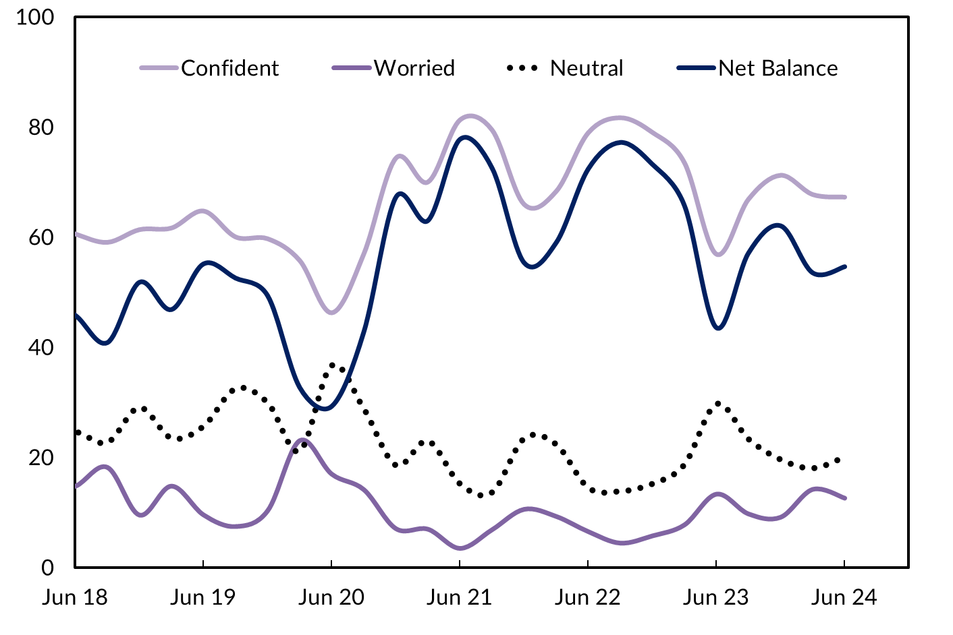 | 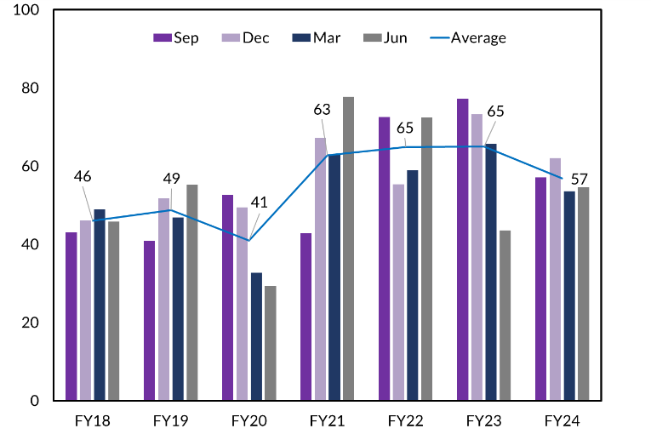

Overall business performance has improved
When asked ‘How is your business performing this year compared to last year?’, 49% of businesses reported improved performance, a 3 ppt increase on the March quarter 2024 and a 5 ppt increase on June quarter 2023 (Table 2 and Chart 3).
Table 2: Business performance compared to last year
 | June qtr 2024 | Quarterly change | Annual change*
Better | 49% | +3ppt | +5ppt
Same | 28% | -7ppt | -7ppt
Worse | 23% | +5ppt | +2ppt
*Current quarter compared with the same quarter in the previous year.
However, the proportion of businesses stating performance this year worsened from last year increased by 5 ppt to 23% in the June quarter, the highest level since December 2020. Compared to June quarter 2023, the proportion of business reporting worsened performance increased by 2 ppt.

Chart 3
Business performance – comparing this year to last – by quarter (%)
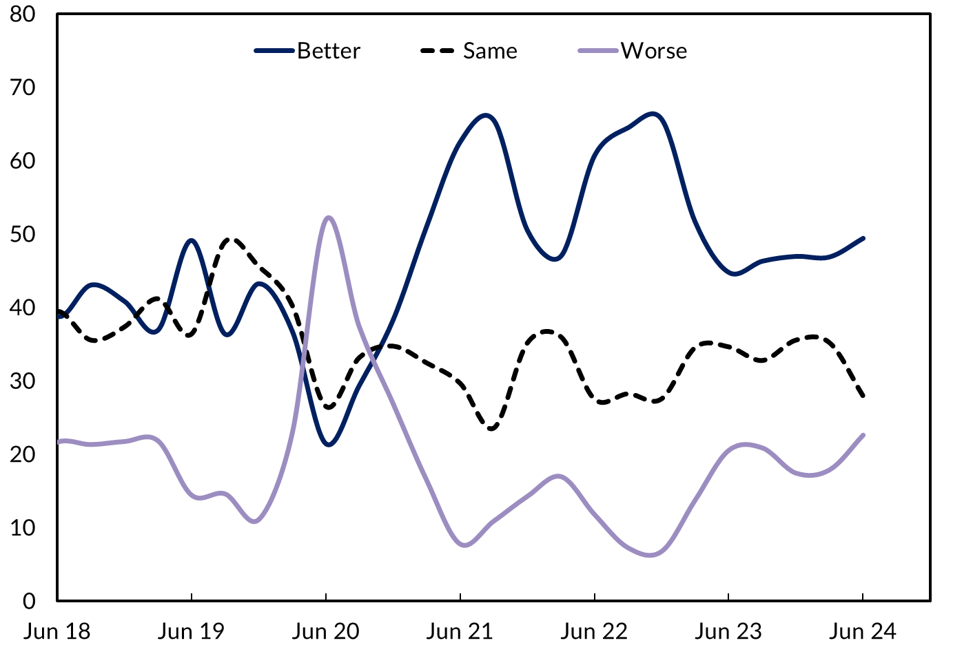

Customer relations & business opportunity drive confidence
Similar to previous quarters, the main reasons for positive business confidence in the Territory are strong customer relations and benefits from being in a business for a long time. In addition, continued business opportunities and strong market position are also cited as important sources of confidence (Chart 4).
Confidence is also likely to be supported by recent media reports detailing the Territory’s $78 billion pipeline of major projects, primarily in the minerals, oil & gas, renewables and defence industries, as well as major investments in enabling infrastructure. These investments have the potential to deliver up to 25,000 private sector jobs.
Chart 4
Reasons for confidence, share of businesses (%)
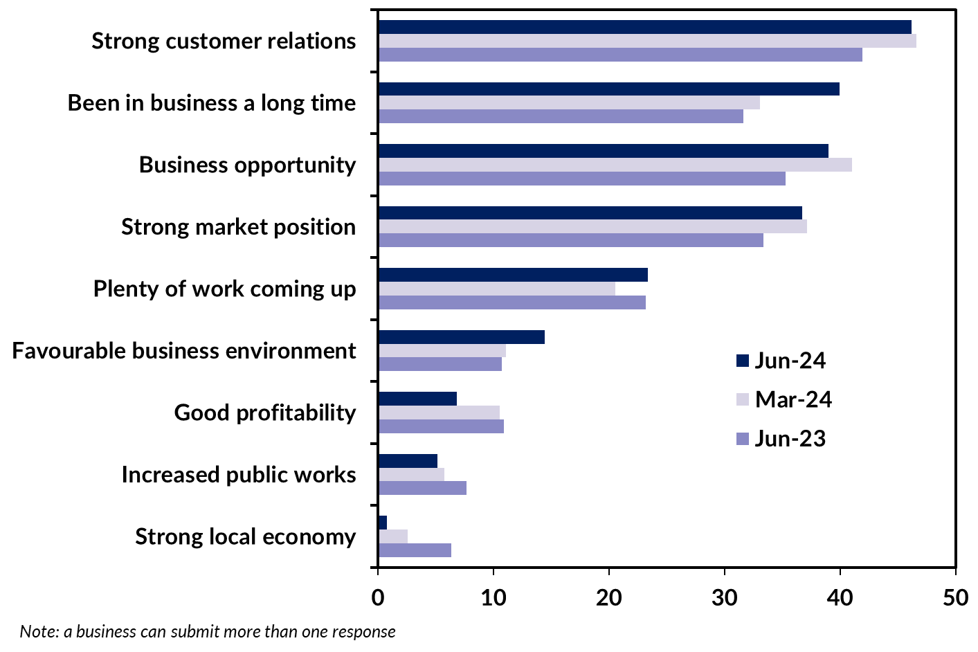
The proportion of businesses reporting ‘plenty of work coming up’ increased by 2 ppt to 23% in the quarter, and ‘favourable business environment’ increased by 3 ppt. This is consistent with the recovery in private sector business investment in the Territory over the past few years (Chart 5).
Chart 5
Territory business expenditure
Year-on-year expenditure ($M), seasonally adjusted
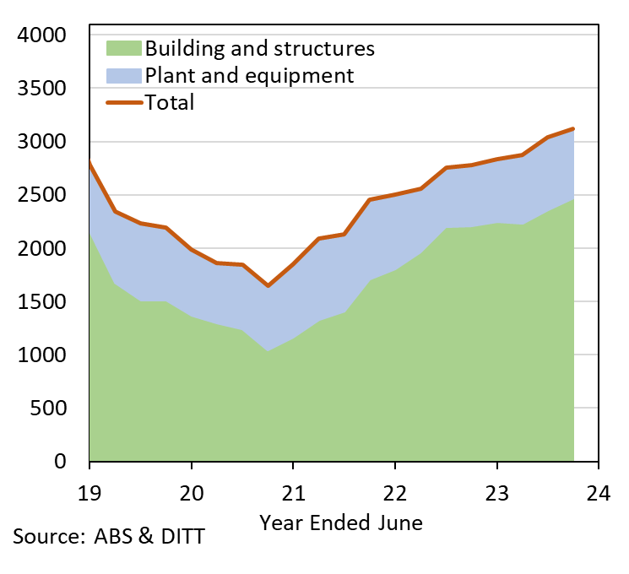

Businesses remain concerned about labour shortages…
Since mid-2020, ‘lack of suitably skilled workers’ has been a consistent concern of Territory businesses, and in the June quarter 2024, 14% of businesses reported being affected by this issue. This is unchanged from the previous quarter and a 3 ppt increase from June quarter 2023 (Chart 6). Responding to question on managing labour shortages, 11% of businesses are actively seeking to attract and hire staff from interstate while around 10% are investing in training and upskilling initiatives (Chart 7).
Chart 6
Reasons for worry, share of businesses (%)
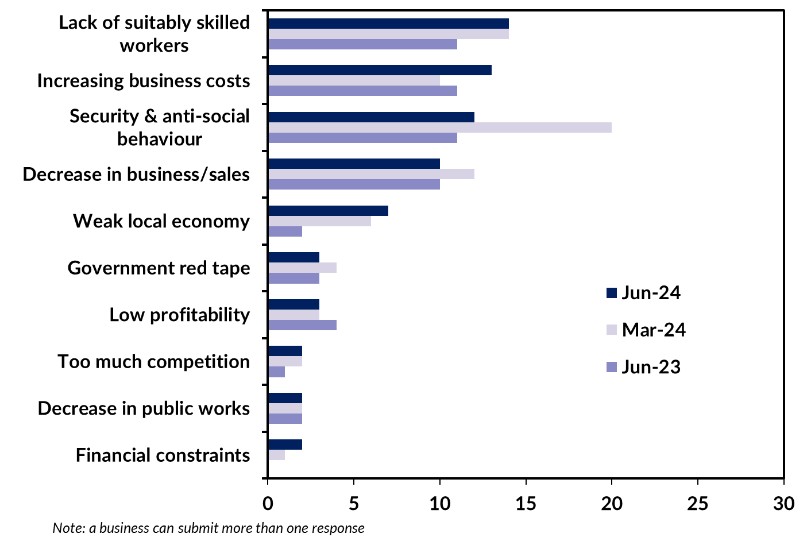

Chart 7
Response to skill shortages (%)
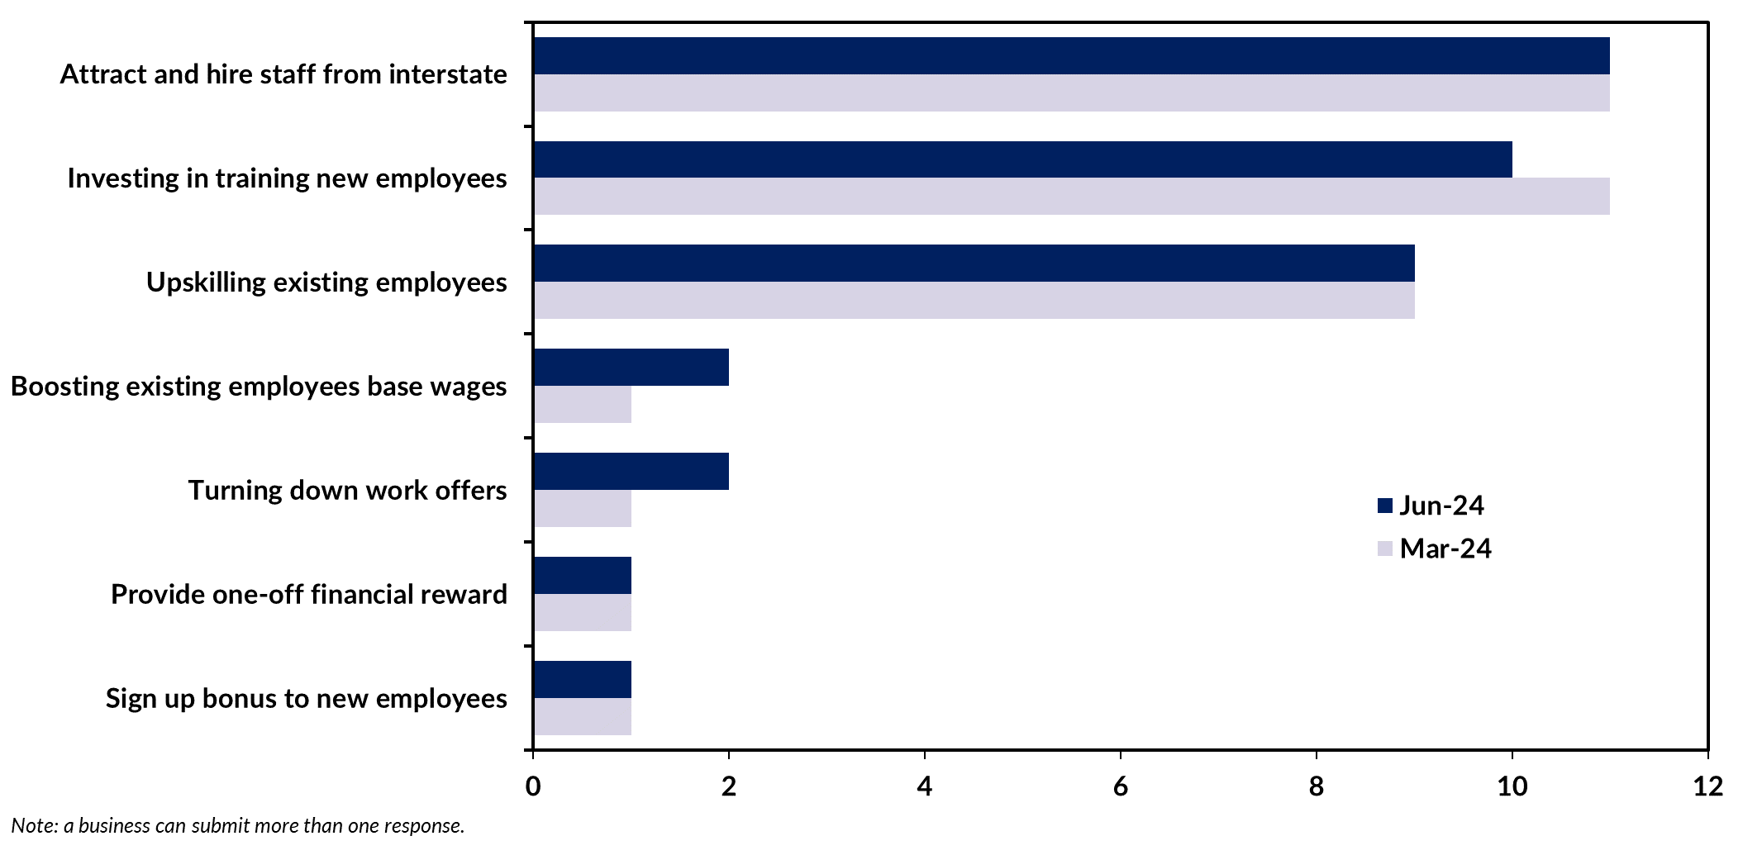

…as well as rising business costs and weak demand
The proportion of businesses reporting ‘increasing business costs’ rose by 3 ppt to 13% in the June quarter 2024. This is consistent with the producer price index (which measures price changes from the perspective of industries that produce goods and services, not consumers) which has been increasing steadily since March 2021, and reported annual growth of 4.3% to the March quarter 2024. Wages growth is also accelerating, and is contributing to higher business costs, with annual wage growth in the Territory at 4.1% in March quarter 2024. Higher production costs are squeezing profit margins while higher interest rates are impacting household discretionary spending, evidenced by weaker ‘real’ retail trade since mid-2021 (Chart 8).
Chart 8
Territory retail trade
Year-on-year growth ($M), Real and nominal
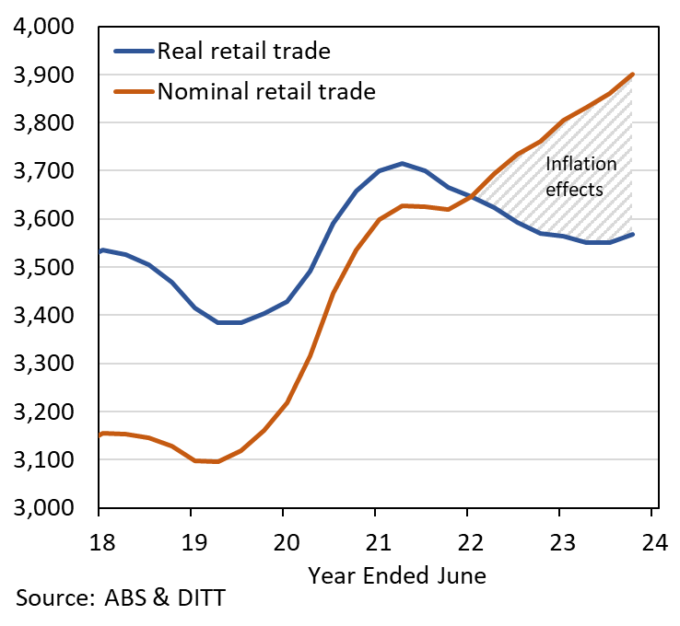

Concerns on security & anti-social behaviour abate slightly
Concerns on security & anti-social behaviour decreased from the most cited business concern in the March quarter 2024 to the third most cited concern this quarter. Compared with the previous quarter, businesses reporting ‘security & anti-social behaviour’ as a concern decreased by 8 ppt to 12%.
The drop was notable in the Big Rivers region, where the proportion of businesses reporting this concern fell from 64% to 25% in the quarter. However, more than half of the businesses surveyed in Katherine town (55%) still reported this as a concern.
In Central Australia the proportion of businesses citing security & anti-social behaviour concerns fell from 20% to 19%. However, results varied across the region, with businesses in Alice Springs recording a drop from 26% to 21%, and the rest of the region reporting an increase from 6% to 14%. During this period, the NT Government employed various measures to address anti-social behaviour including a curfew in Alice Springs in April, and passing legislation in May, giving the NT Police Commissioner power to declare three day curfews to address public disorder risks.

Business confidence is mixed across the regions…
Business confidence and performance varied by region in the quarter (Table 3), with Barkly reporting the highest net balance of +100% and East Arnhem reporting the lowest of 34%. (Small sample size in some regions can contribute to large quarterly movement).
Greater Darwin reported net confidence of 55%, an increase both over the quarter (+1 ppt) and year (+16 ppt) and respondents attributed this to rising business activity, a strong pipeline of projects and promising future opportunities.
Business confidence in Big Rivers region recorded a net balance of +74%, an increase of 8 ppt in the quarter and 43 ppt compared with June quarter 2023.
Central Australia recorded net business confidence of 37%, an improvement of 7 ppt in the quarter, but lower by 30 ppt compared to the June quarter 2023.

…and among the industries
Business confidence varied among the 10 industries with the largest number of respondents, ranging from Education & Training reporting a net balance of 82% to Retail Trade reporting 30% (Chart 10).
Education & Training reported the highest business confidence for the second consecutive quarter, noting a quarterly increase of 1 ppt and an annual increase by 5 ppt (Table 4). Higher international students’ arrivals (up 11% in the year to May 2024) and Commonwealth funding to set up a medical school at the Charles Darwin University are likely to have supported confidence.
Construction industry confidence fell by 9 ppt in the quarter as businesses were impacted by extreme weather events (tropical cyclone Megan), higher interest rates impacting short term demand and ongoing labour shortages.
Similar to previous quarters, business confidence in customer facing sectors is relatively low. This is largely attributable to weaker consumers spending behaviour driven by high inflation and tight monetary policy setting as well as lower tourist numbers. In the year to March 2024, domestic visitation in the Territory fell by 8.5% (1.45 million visitors) while total visitors declined by 3.2% (1.65 million visitors).
Table 3: Business confidence & performance by region
Business Confidence |  |  |  |  | Business Performance
 | Jun qtr 2024 | Quarterly change | Annual change |  |  | Jun qtr 2024 | Quarterly change | Annual change
Territory-wide (n=526) |  |  |  |  | Territory-wide (n=526)
Confident | 67% | 0ppt | +10ppt |  | Better | 49% | +3ppt | +5ppt
Worried | 13% | -2ppt | -1ppt |  | Same | 28% | -7ppt | -7ppt
Net Balance | 55% | +1ppt | +11ppt |  | Worse | 23% | +5ppt | +2ppt
Greater Darwin (n=193) |  |  |  |  | Greater Darwin (n=193)
Confident | 67% | 0ppt | +13ppt |  | Better | 53% | +3ppt | +9ppt
Worried | 12% | -1ppt | -3ppt |  | Same | 24% | -10ppt | -12ppt
Net Balance | 55% | +1ppt | +16ppt |  | Worse | 24% | +7ppt | +3ppt
Daly-Tiwi-West Arnhem (n=33) |  |  |  |  | Daly-Tiwi-West Arnhem (n=33)
Confident | 72% | -22ppt | +1ppt |  | Better | 64% | +1ppt | +3ppt
Worried | 9% | +9ppt | +7ppt |  | Same | 21% | -10ppt | -3ppt
Net Balance | 63% | -32ppt | -6ppt |  | Worse | 15% | +9ppt | +1ppt
East Arnhem (n=38) |  |  |  |  | East Arnhem (n=38)
Confident | 58% | -24ppt | -2ppt |  | Better | 32% | -22ppt | -3ppt
Worried | 24% | +6ppt | +10ppt |  | Same | 54% | +36ppt | +11ppt
Net Balance | 34% | -29ppt | -12ppt |  | Worse | 14% | -14ppt | -8ppt
Big Rivers (n=147) |  |  |  |  | Big Rivers (n=147)
Confident | 82% | +2ppt | +26ppt |  | Better | 36% | +12ppt | -20ppt
Worried | 8% | -6ppt | -17ppt |  | Same | 30% | -15ppt | +24ppt
Net Balance | 74% | +8ppt | +43ppt |  | Worse | 34% | +2ppt | -4ppt
Barkly (n=4) |  |  |  |  | Barkly (n=4)
Confident | 100% | +12ppt | +20ppt |  | Better | 50% | +15ppt | -3ppt
Worried | 0% | -6ppt | -4ppt |  | Same | 50% | 0ppt | +21ppt
Net Balance | 100% | +18ppt | +24ppt |  | Worse | 0% | -15ppt | -18ppt
Central Australia (n=111) |  |  |  |  | Central Australia (n=111)
Confident | 59% | +3ppt | -12ppt |  | Better | 37% | 0ppt | -9ppt
Worried | 22% | -4ppt | +17ppt |  | Same | 48% | +4ppt | +3ppt
Net Balance | 37% | +7ppt | -30ppt |  | Worse | 15% | -3ppt | +5ppt
Note: Caution should be taken when interpreting these results as the sample size in some regions may be relatively small.
Table 4: Business confidence by industry
Sector | June Q 2024 |  | Net Balance
 | Confident | Worried | June Q 24 | Mar Q 24 | June Q 23
Education & training | 88% | 6% | 82 | 81 | 77
Manufacturing | 76% | 0% | 76 | 67 | 67
Professional, scientific & technical services | 78% | 4% | 74 | 76 | 76
Administrative & support services | 65% | 0% | 65 | 76 | 87
Arts & recreation services | 70% | 9% | 61 | 53 | 41
Construction | 77% | 18% | 59 | 68 | 79
Health care & social assistance | 74% | 15% | 59 | 73 | 74
Accommodation & food services | 61% | 22% | 39 | 43 | 44
Other services | 56% | 20% | 36 | 53 | 48
Retail trade | 56% | 26% | 30 | 21 | 35
Chart 10
Business confidence responses by industry (%)
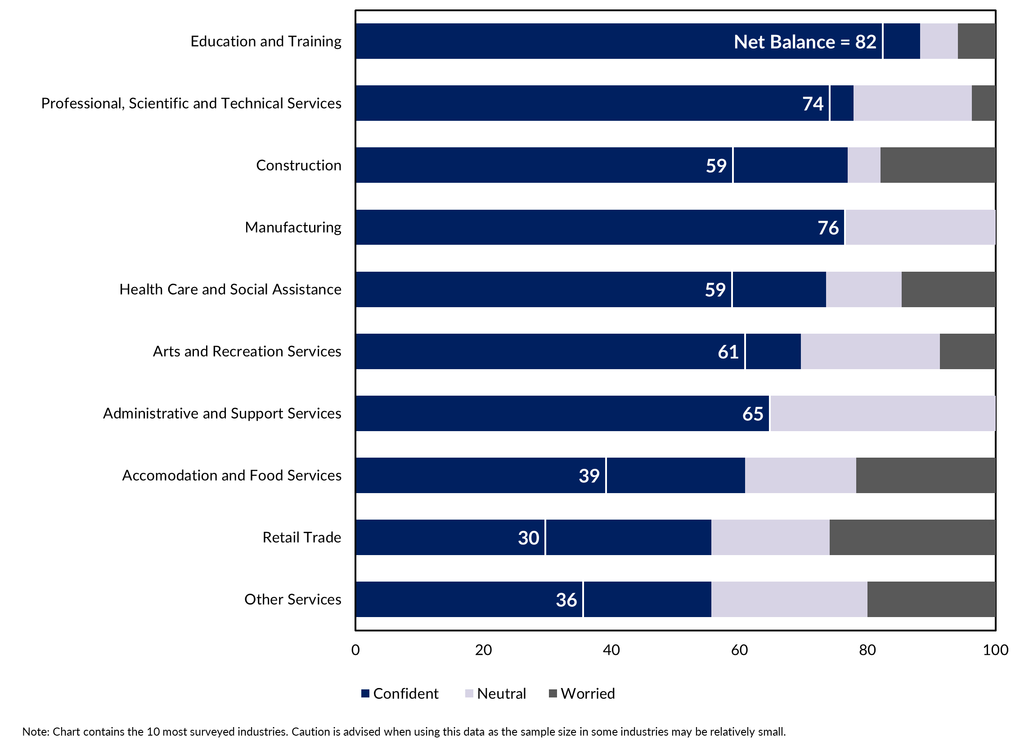

Modest investment intentions
The proportion of businesses planning to invest in new capital and equipment increased by 3 ppt to 25% in the quarter (Figure 2), with 13% of the Territory businesses expecting to invest in new technology in the short to medium term, a drop of 1 ppt in the quarter (Figure 3).
Figure 2 | Figure 3
Expect to invest in capital & equipment | Expect to invest in new technology
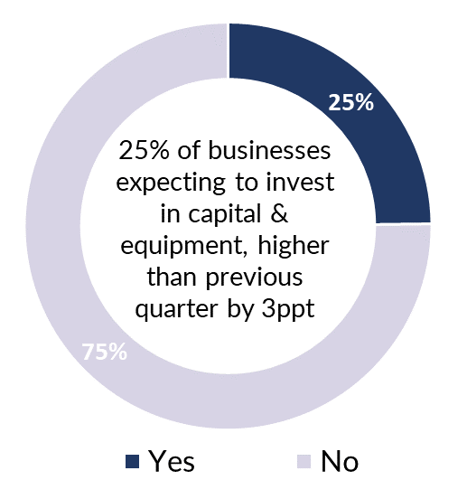 | 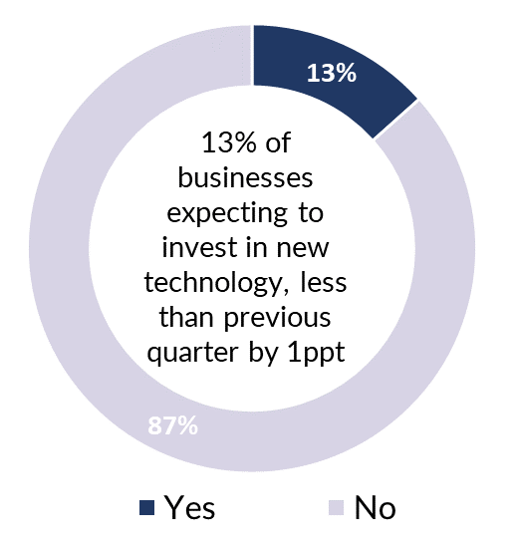

Businesses are confident of revenue growth
A majority of businesses expect input prices to grow faster than unit sale prices putting pressure on margins and profitability (Chart 11). At the same time revenue is expected to grow faster than sale prices, suggesting that businesses expect an increase in demand (as well as prices) across the economy over the coming year.
Chart 11
Business indicators (%)
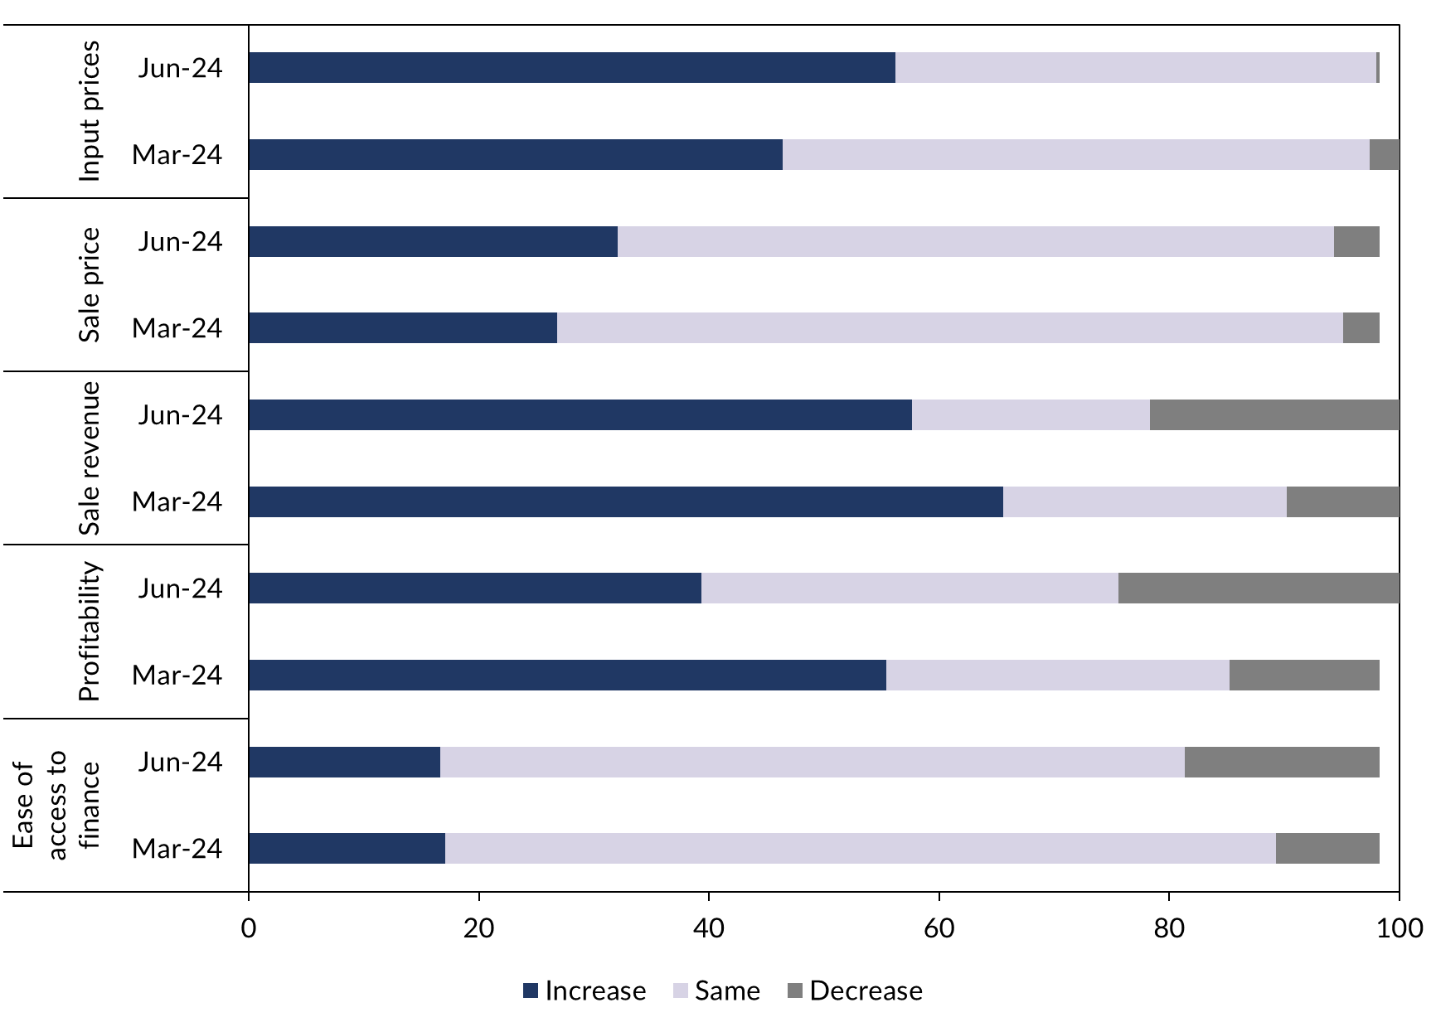

The outlook for business confidence is mixed
Looking ahead, Territory businesses face a mixed outlook. On the positive side, the large pipeline of projects and incentives for the tourism industry are expected to continue to create opportunities for business growth. On the flipside though, concerns about lack of suitably skilled workers, rising business costs and security & anti-social behaviour issues are persistent, and finding effective and enduring solutions to these economic and social issues remains challenging for both the business community and government.

Appendix

Methodology
The Department of Industry, Tourism and Trade conducts a survey of businesses operating in the Territory on a quarterly basis. The results have been used to construct a business confidence index.
The business confidence index is calculated as the difference between the proportion of businesses that are ‘confident about their business prospects for the next 12 months' and the proportion of businesses that are ‘worried about their business prospects for the next 12 months’ (net balance approach).
The Territory-wide confidence index is weighted to account for the number of businesses in each region. The weighted result provides a more balanced reflection of overall business confidence. Business confidence results are also presented by region and industry.
526 businesses were surveyed this quarter out of 16,105 operating businesses in the Territory (Table 4). For the sample survey to achieve a 95% confidence level with a margin of error of 5%, 391 survey responses are required.
Table 5: Survey Numbers
Region | Total number of businesses | Businesses surveyed | Proportion of total
Greater Darwin | 11,907 | 193 | 1.6%
Daly-Tiwi-West Arnhem | 389 | 33 | 8.5%
East Arnhem | 275 | 38 | 13.8%
Katherine | 1,036 | 147 | 14.2%
Barkly | 182 | 4 | 2.2%
Alice Springs | 2,020 | 111 | 5.5%
Total | 16,105 | 526 | 3.3%
Note: Total number of businesses do not add up to individuals due to some businesses missing location information.

From the beginning of survey in December 2016 till June 2024
From the beginning of survey till December 2019

