Overview
State final demand (SFD) decreased by 1.8% in the March quarter, as stronger consumption (1.0%, contributing 0.7 percentage points (ppt) to growth), was more than offset by weaker investment (-9.3%, -2.5 ppt). Private investment declined by 9.8% in the quarter, as weaker mining-related investment impacted engineering construction (-18.3%) and purchases of machinery and equipment (-12.1%). Public investment decreased by 8.0% in the quarter as work for major road and utilities infrastructure projects neared completion.
Household consumption increased by 1.0% in the quarter, with a notable increase in electricity spending (12.9%) due to decrease in energy rebates and a rise in demand. Other categories such as food (1.0%), hotels, accommodation and cafes (1.8%) and transport services (6.8%) also increased. Government consumption increased by 1.0%, supported by increased spending across health and social programs.
Given the project-based nature of private investment in the Territory, sustained growth in tourism can have a stabilising impact on domestic economic activity, with significant localised benefits. Government incentives, the recent easing in inflation and growth in real wages (Chart 2) are supporting spending, but visitation remains below pre-pandemic levels (Chart 3) and is projected to recover at a sluggish pace (Chart 4) as it faces several downside risks.
Indicator | Most recent | Measure | Period change¹ | Annual change² | Year on Year³ | COVID period change⁴
Economic Growth |  | $B
State final demand (NT) (sa) | Mar-24 | 7.535 | -1.8% | 2.6% | 2.1% | 17.1%
Consumption |  | 5.695 | 1.0% | 3.1% | 2.2% | 10.5%
Investment |  | 1.84 | -9.3% | 1.2% | 2.0% | 38.7%
Domestic final demand (Aus) (sa) | Mar-24 | 583.577 | 0.2% | 2.3% | 2.7% | 13.5%
Consumption |  | 440.658 | 0.6% | 2.1% | 1.9% | 12.4%
Investment |  | 142.919 | -0.9% | 2.9% | 5.4% | 17.2%
Gross state product (NT) | 2022-23 | 30.123 | na | na | -5.2% | na
Gross domestic product (Aus) | 2022-23 | 2406.726 | na | na | 3.2% | na
Partial Indicators |  | $B
Nominal retail sales (NT) (sa) | Apr-24 | 0.331 | 0% | 3.8% | 3.7% | 25.4%
Nominal retail sales (Aus) (sa) | Apr-24 | 35.714 | 0.1% | 1.3% | 2.0% | 29.8%
Construction work done (NT) (sa) | Mar-24 | 0.747 | -14.9% | -1.1% | 6.0% | 44.3%
Construction work done (Aus) (sa) | Mar-24 | 64.032 | -2.9% | 1.8% | 7.6% | 11.7%
Residential building activity (NT) | Dec-23 | 0.07 | -26.9% | -20.1% | 0.1% | -1.6%
Residential building activity (Aus) | Dec-23 | 19.577 | -8.3% | -2.5% | 1.0% | -4.8%
Nominal goods exports (NT) | Apr-24 | 0.904 | -13.8% | -9.0% | -10.7% | 21.2%
Nominal goods exports (Aus) (sa) | Apr-24 | 43.320 | -2.5% | -5.9% | -10.3% | 39.3%
Prices |  | Annual Δ²
Inflation (Darwin) | Mar-24 | 3.3% | -0.6 ppt | -2.9 ppt | na | 3.6 ppt
Inflation (8 Capitals) | Mar-24 | 3.6% | -0.4 ppt | -3.4 ppt | na | 3.1 ppt
WPI growth (NT) | Mar-24 | 4.1% | -0.2 ppt | 1.2 ppt | na | 1.7 ppt
WPI growth (Aus) | Mar-24 | 4.1% | -0.2 ppt | 0.5 ppt | na | 1.7ppt
Employment |  | #M
Employment (NT) (sa) | May-24 | 0.139 | -0.4% | 0.7% | 1.6% | 5.3%
Employment (Aus) (sa) | May-24 | 14.356 | 0.3% | 2.5% | 3.0% | 10.6%
Unemployment |  | Rate
Unemployment rate (NT) (sa) | May-24 | 4.1% | 0 ppt | 0 ppt | na | -1.7 ppt
Unemployment rate (Aus) (sa) | May-24 | 4.0% | -0.1 ppt | 0.4 ppt | na | -1.3 ppt
Population |  | #M
Population (NT) | Dec-23 | 0.254 | 0% | 0.9% | na | 2.7%
Population (Aus) | Dec-23 | 26.967 | 0.5% | 2.5% | na | 5.3%
1. Monthly change for retail sales, goods exports, employment and unemployment; quarterly change for all other variables.
2. Compares the latest period with the same period last year.
3. Compares the 12 months up to and including the latest period with the previous 12-month period.
4. Compares the 12 months up to and including latest period with the year to December 2019 period, using original data.
Chart 1: In the year to March 2024, Territory SFD increased by 2.0%, with contributions from increased government investment (13.9%, 0.9 ppt) and consumption (2.9%, 1.0 ppt). Household consumption remained resilient (1.2%, 0.5 ppt) despite high inflation and interest rates impacting confidence. Private investment contracted (-2.1%, -0.4 ppt) in the year. Business confidence has weakened over the year, but a major impact on the decline relates to the timing of activity to progress the Barossa gas project. | Chart 2: Household consumption is the largest contributor to demand in the Territory (typically accounting for around 40% of demand) and has been growing year-on-year since June 2023. Easing inflation and real wage growth contributed to stronger household spending in the March quarter. Looking ahead, household budgets will be supported by a continued tight labour market (contributing to real wage growth), personal income tax cuts from 1 July 2024 and expectations of easing inflation and interest rate relief.
State Final Demand (original) – NT  Components, moving annual total ($B)  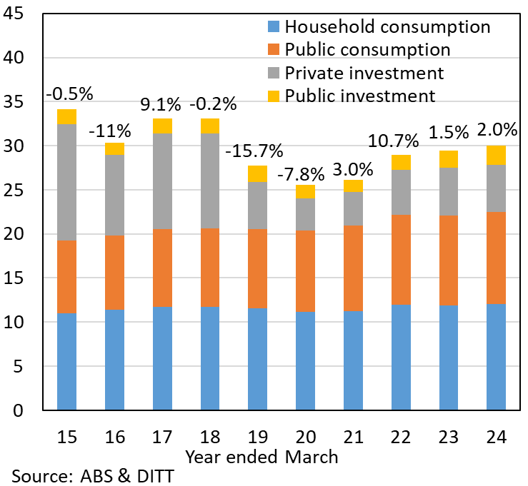 | Essentials Inflation and Real Wages  Annual change (%), Index: June 2016 = 100  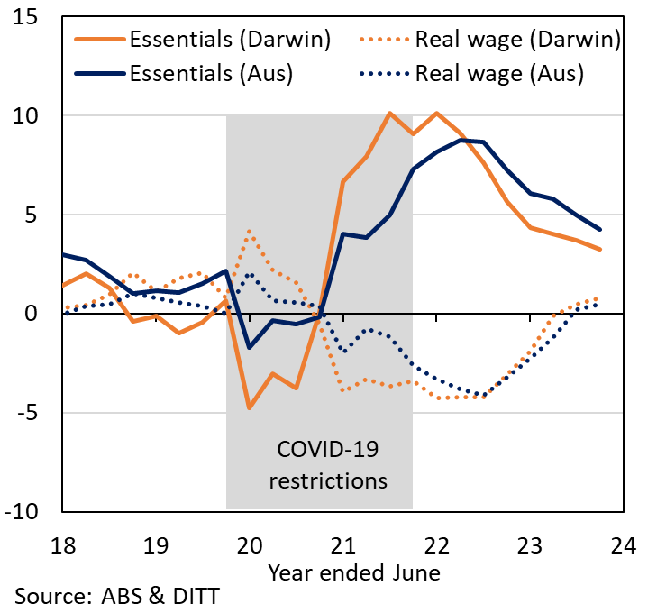
Chart 3: Tourism is an important sector in the Territory, accounting for 3.8% of output and 5% of employment in 2022-23. After peaking in 2019-20, both domestic and international visitation are well below pre-pandemic levels, and decreased by 3.2% to 1.65 million visitors in the year to March 2024. Domestic visitation is down by 8.5%, with an increased preference for overseas travel. Growing domestic holiday and other visitation is important for sustained economic and employment growth, especially as domestic visitors accounted for 88% of visitors to the Territory in the year to March 2024. | Chart 4: Tourism Research Australia expects domestic visitor nights in the Territory to increase by 3.6% in 2024 and to recover to pre-pandemic levels by 2027. However, the outlook continues to be challenged by stiff competition from overseas and domestic destinations, concerns regarding security and safety in the Territory, limited flight connections and high airfares. Tourism is a highly competitive market, and ongoing investment in experiences, infrastructure, transport connections and marketing is crucial if the Territory is to maintain its standing as a destination of choice for both domestic and international visitors.
Overnight Visitors – NT  Components, moving annual total (‘000)  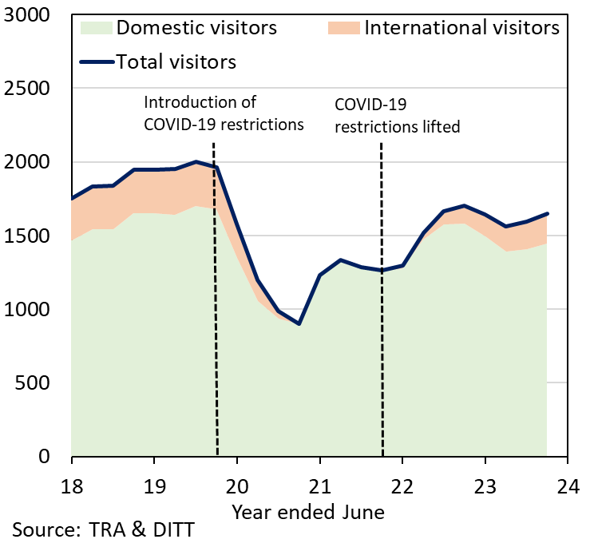 | Domestic Visitor Nights – NT  Year-on-Year change (%)  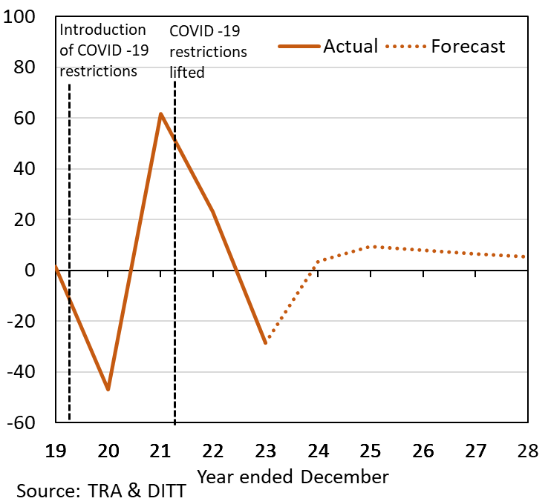
The Northern Territory of Australia exercised due care and skill to ensure that at the time of publication the information contained in this publication is true and correct. However, it is not intended to be relied on as professional advice or used for commercial purposes. The Territory gives no warranty or assurances as to the accuracy of the information contained in the publication and to the maximum extent permitted by law accepts no direct or indirect liability for reliance on its content.

