NT population
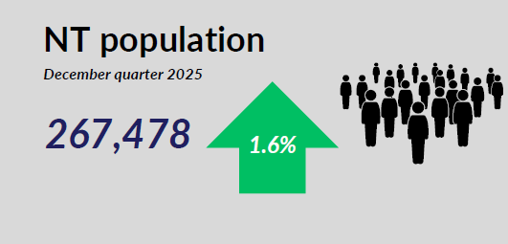

- As of December 2025, Northern Territory population was 267,478, annual increase of 1.6%.

Labour market
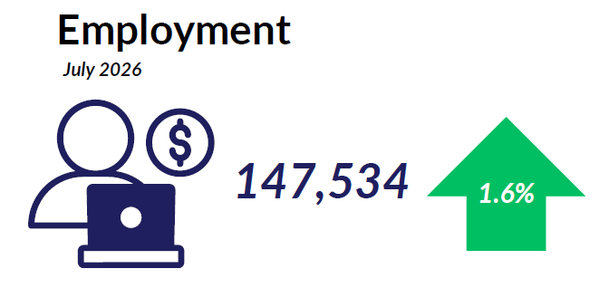
- As of July 2026, the number of employed people in the Territory was 147,534, up by 1.6% annually.

Labour market
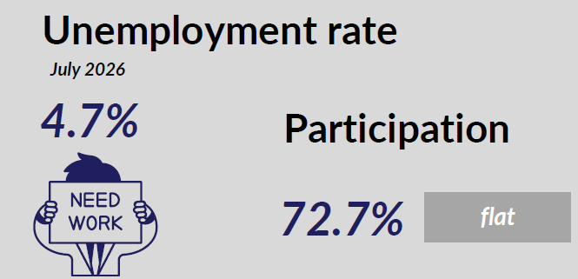
As of July 2026:
  - The unemployment rate in the Territory was 4.7%
  - Participation rate in the Territory was 72.7%, which was flat compared to June 2025

Average weekly earnings
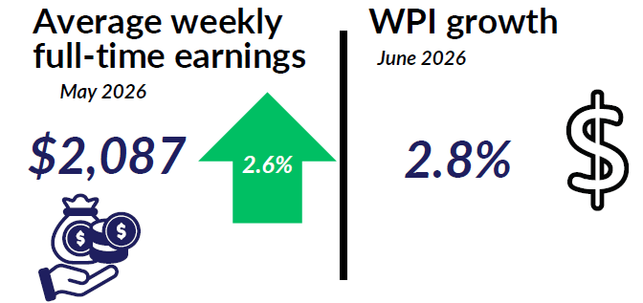
- Average weekly earnings (trend) in the NT are $2,087 as of May 2026, annual increase of 2.6%
- WPI in the NT increased by 2.8% annually in June 2026.

Internet job vacancies

- In July 2026, NT’s internet job vacancies decreased by 7.9% compared to July 2025.

Industry share of output

- In 2024-25, top 5 industries as the share of GSP:
  - Mining: 24.6%
  - Public administration and safety: 10.3%
  - Health: 8.7%
  - Construction: 6.1%
  - Education: 5.0%

NT businesses
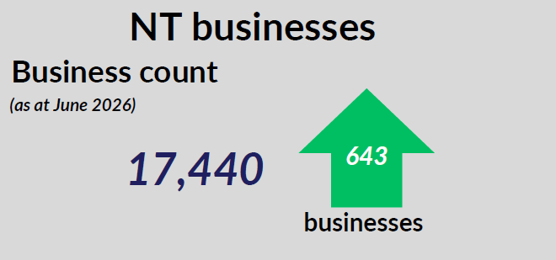
- As of June 2026, the number of businesses in the Territory was 17,440. This was an increase of 643 businesses compared to June 2025.

Business turnover
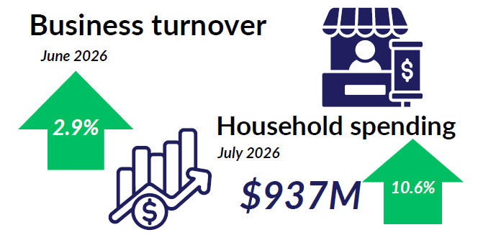
- In June 2026, business turnover of NT businesses (all industries) increased by 2.9%.
- In July 2026 household spending was $937M, an increase of 10.6% compared to July 2025.

International trade in goods
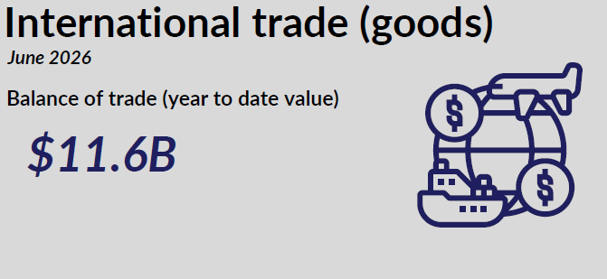
- NT’s balance of trade was $11.6 billion in the year to June 2026

International student enrolments
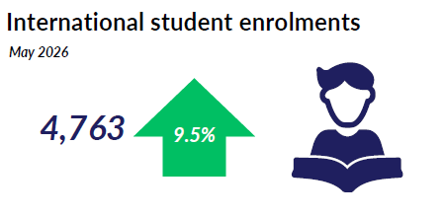
- As of May 2026, the number of international student enrolments in the Territory increased by 9.5% to 4,763 students.

NT Department of Trade, Business and Asian Relations
t: 08 8999 5139
industry.nt.gov.au

