Introduction
The Australian Bureau of Statistics released high-level business counts data for 2023-24 on 27 August 2024, with detailed data by industry, turnover, employment and location to be released in December 2024.

Territory business growth remains positive
The number of operating businesses increased by 1.7% to 16,380 in the Territory in 2023-24, and by 2.8% nationally (Table 1). Of the jurisdictions, Western Australia and the Australian Capital Territory (ACT) reported the highest growth rate (3.5%) and Tasmania the lowest (1.4%).
Table 1: Business Counts for 2023-24
 | Jun-24 | Jun-23 | Change | Change (%) | Entries | Entry rate (%) | Exits | Exit rate (%)
NT | 16,380 | 16,107 | 273 | 1.7 | 2,743 | 17.0 | 2,347 | 14.6
AUS | 2,662,998 | 2,589,873 | 73,125 | 2.8 | 436,018 | 16.8 | 362,893 | 14.0

Entry and exit rates comparable to nationally
The Territory’s business entry rate was steady at 17% in 2023-24, while nationally it increased from 16% to 16.8% (Chart 1). In 2023-24, except for Tasmania, all jurisdictions reported the same or increased business entry rates compared to 2022-23, and this ranged from 13.9% in Tasmania to 18.5% in the ACT.
The exit rate in the Territory was 14.6%, slightly higher than the national rate of 14%. Victoria (14.7%) recorded the highest exit rate while Tasmania (12.1%) had the lowest. Except for Victoria, all jurisdictions reported the highest exit rates in a decade.
Historically, the Territory has the lowest number of businesses per capita of the jurisdictions. In 2023-24, the Territory had 65 businesses per 1,000 people (up from 64 last year), but below the national average of 99 businesses per 1,000 people (unchanged from last year) (Chart 2).
Chart 1  Business entry and exit rates | Chart 2  Businesses per 1000 people, 2023-24
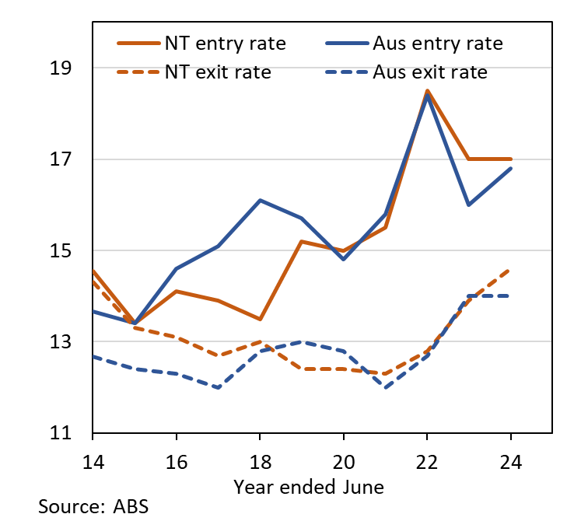 | 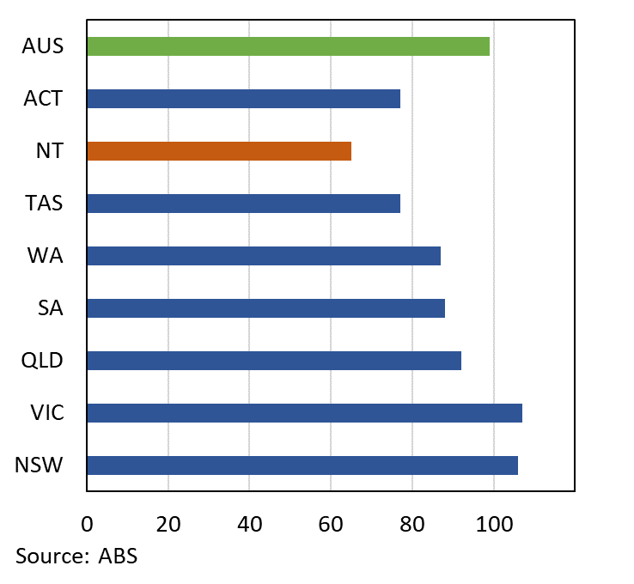

New businesses have slightly lower survival rate than nationally
While the overall survival rates of Territory businesses are similar to national rates (Chart 3), the survival rates of new businesses remain marginally below the national rates (Chart 4).
Chart 3 | Chart 4
Survival Rates (%) | Survival Rates of New Entries (%)
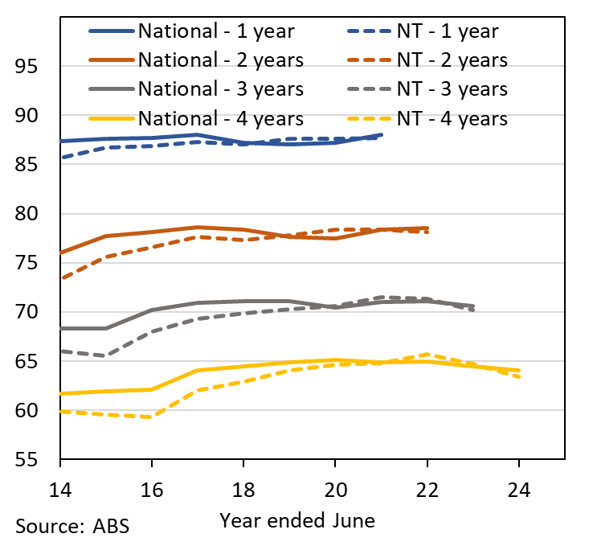 | 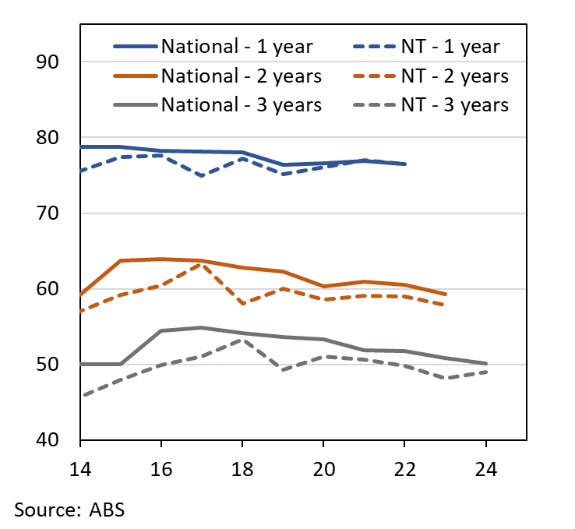

Medium and large businesses increased nationally
Nationally, large (200+ employees) and medium (20 to 199 employees) sized businesses reported the strongest growth in numbers in 2023-24, while small employing businesses (1 to 19 employees) reported a second consecutive year of decline (Chart 5). The number of non-employing businesses increased by 78,144 (4.9%), though 33,783 (43%) of these were formerly employing businesses.

Transport, postal & warehousing industry had the highest growth
Nationally, the Transport, Postal & Warehousing and Health Care & Social Assistance industries reported the largest increase in business numbers in 2023-24 (Chart 6). ABS’s quarterly data reports that Postal, Courier Pick-up & Delivery Services recorded the highest growth (20.6%) and the highest entry rate (55.3%) for the third consecutive year. This is likely driven by post-pandemic preference for online shopping (144% increase in 2023-24 compared to 2018-19 or 21% average annual growth) and increased demand for gig economy workers required to register for an ABN.
Chart 5  Growth by employees, Australia (%) | Chart 6  Business growth and industry contributions
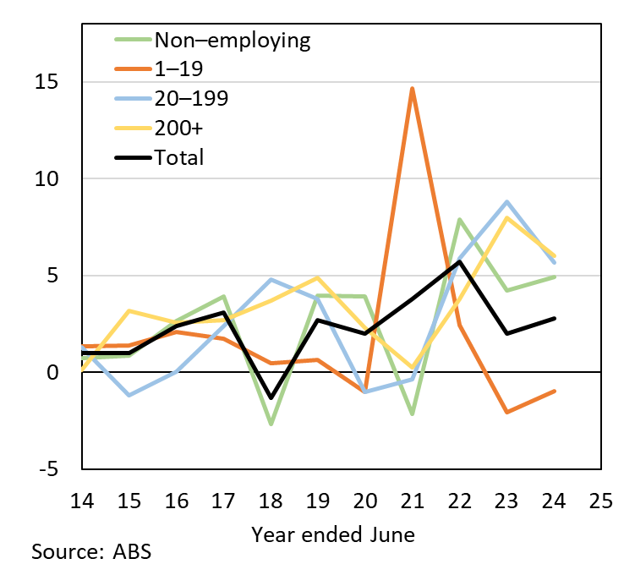 | 