- The Australian Bureau of Statistics (ABS) released preliminary business counts data for 2024-25 on 26 August 2025.
- In 2024-25, the number of businesses operating in the Territory rose by 2.5% or 416 businesses to 16,796 businesses (Table 1), following 1.7% growth in 2023-24.
- Over the past four years (July 2021 to June 2025), the number of Territory businesses has grown on average by 3% annually, slightly below the 3.3% average growth nationally.
- Among the jurisdictions, growth in business numbers was highest in Western Australia (4.3% and 10,877 businesses) and lowest in Tasmania (0.5% and 218 businesses). However, New South Wales registered the largest net increase in the number of businesses at 20,040 and 2.2% growth.
- The Territory’s business entry rate remained steady at 17%, above the national rate (16.4%) (Chart 1). Entry rates fell in most jurisdictions except Western Australia, and ranged from 12.7% in Tasmania to 17.4% in the ACT.
- The Territory’s exit rate was 13.7%, slightly below the national rate of 13.9%, and improved from 14.6% in the previous year. The ACT recorded the highest exit rate (15.1%) while Tasmania had the lowest (12.1%).
Table 1: Business Counts for 2024-25
 | Jun-25 | Annual Change | Change (%) | Entries | Entry rate (%) | Exits | Exit rate (%)
NT | 16,796 | 416 | 2.5 | 2,786 | 17.0 | 2,238 | 13.7
AUS | 2,729,648 | 66,650 | 2.5 | 437,150 | 16.4 | 370,500 | 13.9
- The Territory had 64 businesses per 1,000 people, down from 65 last year, below the national average of 100 businesses per 1,000 people, and is the lowest of the jurisdictions (Chart 2).

Chart 1  Business entry and exit rates | Chart 2  Businesses per 1000 people, 2024-25
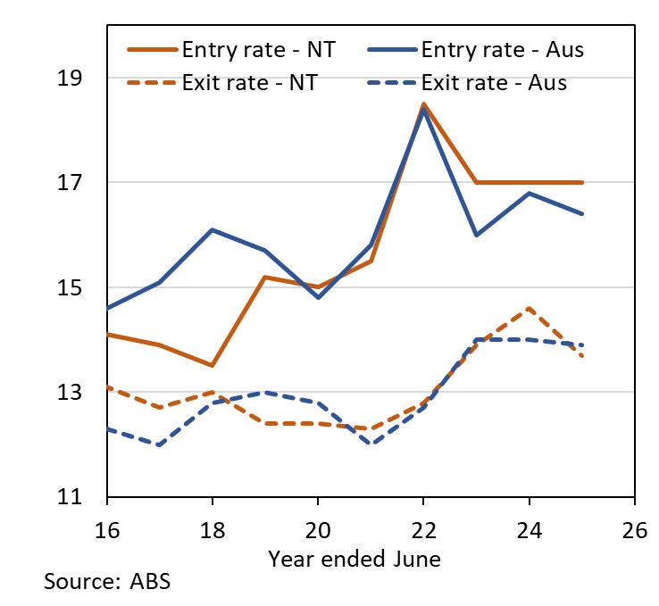 | 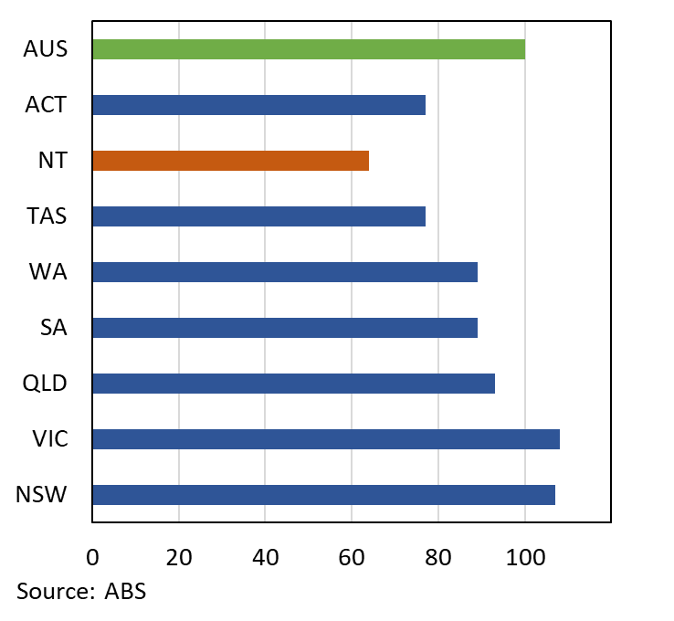

- The Territory’s overall business survival rate was 62.8%, closely aligned to the national rate (63.1%) (Chart 3). However, the survival of new Territory businesses (49.2%) was slightly higher than nationally (48%) (Chart 4), reflecting a national decline compared with the last year, while the Territory’s rate remained steady.
Chart 3 | Chart 4
Survival Rates (%) | Survival Rates of New Entries (%)
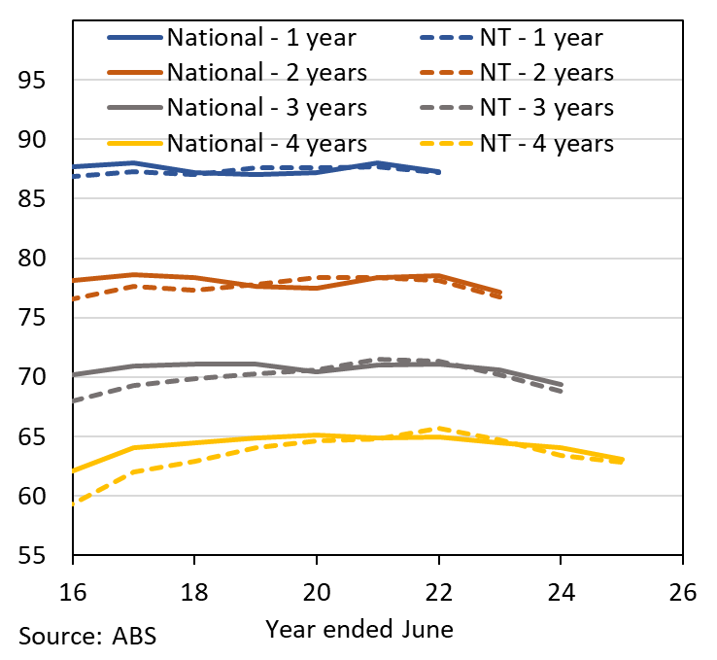 | 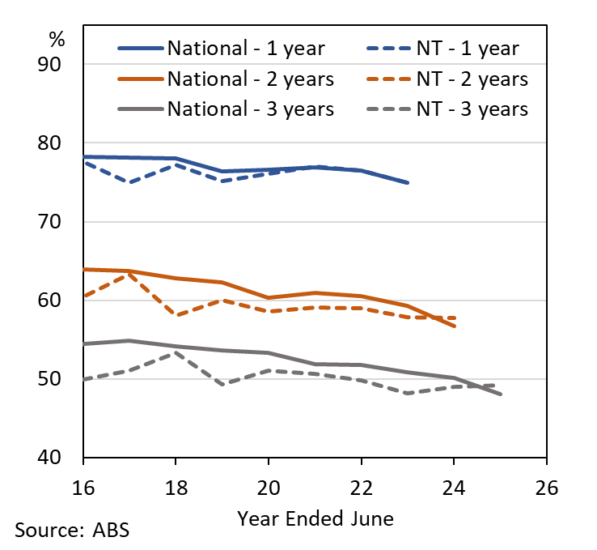

- ABS will release detailed data by industry, turnover, employment and location in December 2025.

Analytics and Insights
September 2025

