NT population
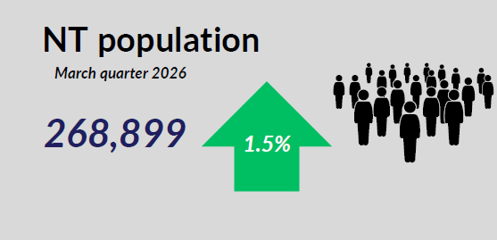
- As of March 2026, Northern Territory population was 268,899, annual increase of 1.5%.

Labour market
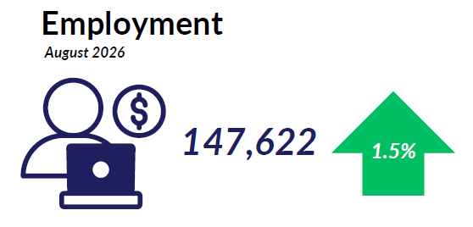
- As of August 2026, the number of employed people in the Territory was 147,622, up by 1.5% annually.

Labour market
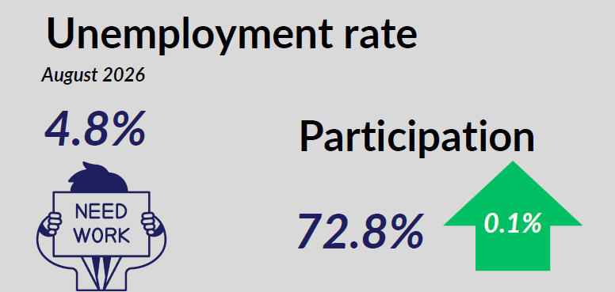
As of August 2026:
  - The unemployment rate in the Territory was 4.8%
  - Participation rate in the Territory was 72.8%, which increased by 0.1% compared to August 2025

Average weekly earnings
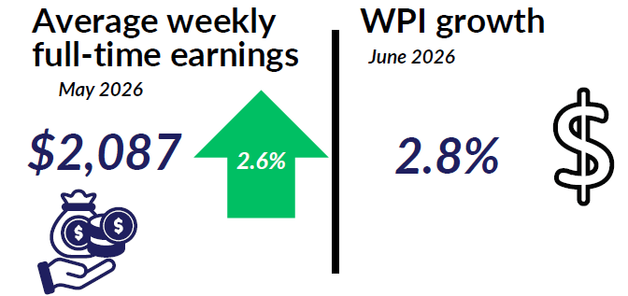
- Average weekly earnings (trend) in the NT are $2,087 as of May 2026, annual increase of 2.6%
- WPI in the NT increased by 2.8% annually in June 2026.

Internet job vacancies

- In August 2026, NT’s internet job vacancies decreased by 5.9% compared to August 2025.

Industry share of output
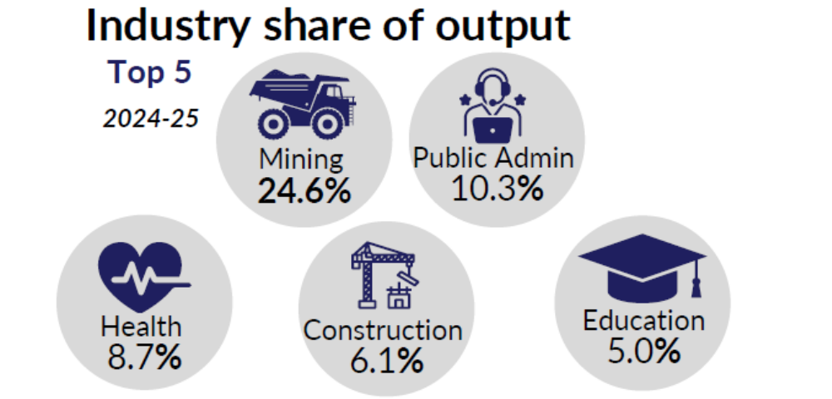

- In 2024-25, top 5 industries as the share of GSP:
  - Mining: 24.6%
  - Public administration and safety: 10.3%
  - Health: 8.7%
  - Construction: 6.1%
  - Education: 5.0%

NT businesses
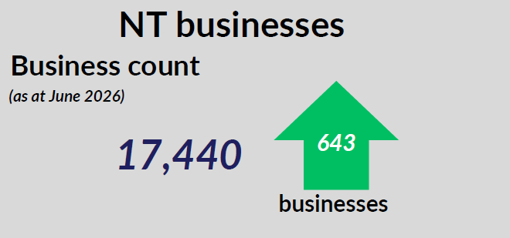
- As of June 2026, the number of businesses in the Territory was 17,440. This was an increase of 643 businesses compared to June 2025.

Business turnover
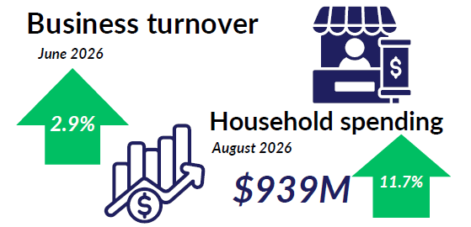
- In June 2026, business turnover of NT businesses (all industries) increased by 2.9%.
- In August 2026 household spending was $939M, an increase of 11.7% compared to August 2025.

International trade in goods
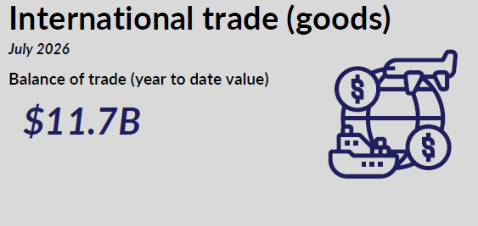
- NT’s balance of trade was $11.7 billion in the year to July 2026

International student enrolments
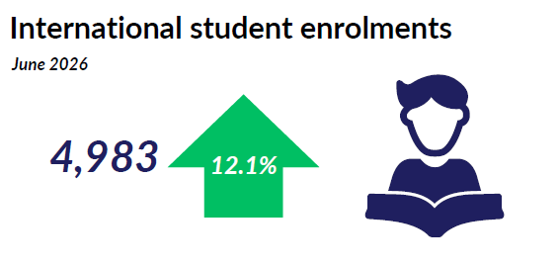
- As of June 2026, the number of international student enrolments in the Territory increased by 12.1% to 4,983 students.

NT Department of Trade, Business and Asian Relations
t: 08 8999 5139
industry.nt.gov.au

