NT population
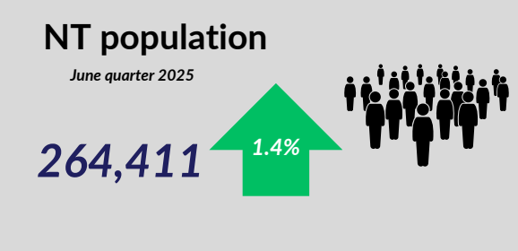

- As of June 2025, Northern Territory population was 264,411, annual increase of 1.4%.

Labour market
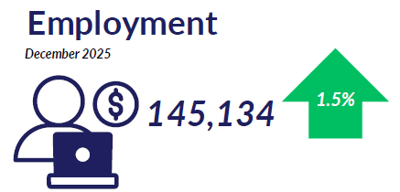
- As of December 2025, the number of employed people in the Territory was 145,134, up by 1.5% annually.

Labour market
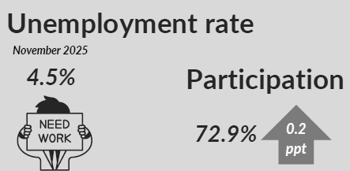
As of November 2025:
  - The unemployment rate in the Territory was 4.5%
  - Participation rate in the Territory was 72.9%, up by 0.2 ppt compared to November 2024

Average weekly earnings
- Average weekly earnings (trend) in the NT is $2,042 as of May 2025, annual increase of 4.4%
- WPI in the NT increased by 3% annually in September 2025, unchanged from September 2024

Internet job vacancies


- In December 2025, NT’s internet job vacancies decreased by 11.4% compared to December 2024.

Industry share of output

- In 2024-25, top 5 industries as the share of GSP:
  - Mining: 24.6%
  - Public administration and safety: 10.3%
  - Health: 8.7%
  - Construction: 6.1%
  - Education: 5.0%

NT businesses
- As of June 2025, the number of businesses in the Territory was 16,796. This was an increase of 416 businesses compared to June 2024.

Business turnover
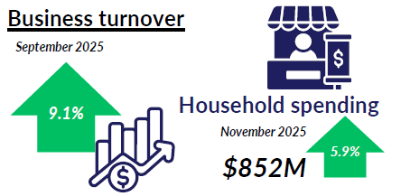

- In September 2025, business turnover of NT businesses (all industries) increased by 9.1%
- In November 2025 household spending was $852M, an increase of 5.9% compared to November 2024

International trade in goods
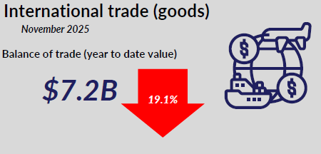
- NT’s balance of trade was $7.2 billion in the year to November 2025, a decrease of 19.1% compared to same period previous year.

International student enrolments

- As of October 2025, the number of international student enrolments in the Territory increased by 3.7% to 5,577 students.

NT Department of Trade, Business and Asian Relations
t: 08 8999 5139
industry.nt.gov.au

