Overview
State final demand (SFD) increased by 4.9% in the June quarter, the strongest of the jurisdictions. Growth in the quarter was driven by private investment which increased by 21.6% and contributed 3.8 percentage points (ppt) to growth, reflecting stronger mining-related investment and construction activity. Public investment was also a significant contributor to growth, increasing by 12.6% in the quarter (0.9 ppt) due to increased spending on utilities, transport, and telecommunication infrastructure and defence.
Household consumption reported modest growth in the quarter (0.1%), with higher spending on health, furnishings & household equipment and energy, partly offset by weaker spending in discretionary categories. Government consumption increased by 0.6% in the quarter, supported by non-employee expenses in transport, health, and safety.
Housing is currently a ‘hot’ national issue as supply and demand factors impact access and affordability. This is being felt by renters and owner-occupiers, and across social and private housing markets, and is contributing to robust policy debate. Residential investment in the Territory has been weak for several years and is contributing to constrained supply and low rental vacancy rates (Chart 3). The prospect of major projects proceeding, and defence relocations is increasing investor interest (Chart 4), and new nation-leading incentives will support owner-occupiers and much needed ‘new builds’.
Indicator | Most recent | Measure | Period change¹ | Annual change² | Year on Year³ | COVID period change⁴
Economic Growth |  | $B
State final demand (NT) (sa) | Jun-24 | 7.928 | 4.9% | 8.1% | 4.1% | 19.8%
Consumption |  | 5.725 | 0.3% | 2.8% | 2.5% | 11.6%
Investment |  | 2.202 | 19% | 24.9% | 8.7% | 47.6%
Domestic final demand (Aus) (sa) | Jun-24 | 585.365 | 0.2% | 1.5% | 2.4% | 14.0%
Consumption |  | 442.182 | 0.3% | 1.8% | 1.8% | 12.9%
Investment |  | 143.183 | -0.1% | 0.6% | 4.1% | 17.6%
Gross state product (NT) | 2022-23 | 30.123 | na | na | -5.2% | na
Gross domestic product (Aus) | 2022-23 | 2406.726 | na | na | 3.2% | na
Partial Indicators |  | $B
Nominal retail sales (NT) (sa) | Jul-24 | 0.337 | 0.5% | 4.5% | 3.7% | 26.7%
Nominal retail sales (Aus) (sa) | Jul-24 | 36.16 | 0% | 2.3% | 1.9% | 30.6%
Construction work done (NT) (sa) | Jun-24 | 0.874 | 15.8% | 6.3% | 5.5% | 47.0%
Construction work done (Aus) (sa) | Jun-24 | 64.932 | 0.1% | 1.2% | 5.5% | 12.5%
Residential building activity (NT) | Mar-24 | 0.074 | -3.2% | -12.7% | -5.2% | -2.7%
Residential building activity (Aus) | Mar-24 | 18.49 | -6.4% | -2.4% | 1.5% | -5.0%
Nominal goods exports (NT) | Jul-24 | 0.921 | -18.2% | -13.3% | -17.3% | 16.9%
Nominal goods exports (Aus) (sa) | Jul-24 | 43.803 | 0.7% | -1.4% | -8.5% | 37.0%
Prices |  | Annual Δ²
Inflation (Darwin) | Jun-24 | 3.0% | -0.3 ppt | -2.3 ppt | na | 3.1 ppt
Inflation (8 Capitals) | Jun-24 | 3.8% | 0.2 ppt | -2.2 ppt | na | 2.6 ppt
WPI growth (NT) | Jun-24 | 3.8% | -0.3 ppt | 0.5 ppt | na | 1.8 ppt
WPI growth (Aus) | Jun-24 | 4.1% | 0 ppt | 0.4 ppt | na | 1.8 ppt
Employment |  | #M
Employment (NT) (sa) | Aug-24 | 0.139 | -0.7% | 2.1% | 1.9% | 5.9%
Employment (Aus) (sa) | Aug-24 | 14.459 | 0.3% | 2.7% | 2.7% | 11.2%
Unemployment |  | Rate
Unemployment rate (NT) (sa) | Aug-24 | 4.2% | -0.1 ppt | -0.7 ppt | na | -1.8 ppt
Unemployment rate (Aus) (sa) | Aug-24 | 4.2% | -0.1 ppt | 0.5 ppt | na | -1.2 ppt
Population |  | #M
Population (NT)  Population (Aus) | Mar-24  Mar-24 | 0.254  27.122 | 0.2%  0.6% | 0.8%  2.3% | na  na | 3.0%  5.9%
1. Monthly change for retail sales, goods exports, employment, and unemployment; quarterly change for all other variables.
2. Compares the latest period with the same period last year.
3. Compares the 12 months up to and including the latest period with the previous 12-month period.
4. Compares the 12 months up to and including latest period with the year to December 2019 period, using original data.
Chart 1: In 2023-24, Territory SFD increased by 4.1%, following a 1.4% rise in 2022-23. Growth was underpinned by business investment (8.6%, 1.3ppt) and public consumption (3.7%, 1.3ppt), with public investment contributing 1 percentage point. Household consumption has been resilient (1.5%, 0.6ppt) in the face of high inflation and tight monetary policy, but private investment in new housing continues to be negatively impacted in the Territory and nationally. Dwelling investment as a proportion of SFD is below the long-term average: 2.2% vs 3.9% locally, and 5% vs 6.6% nationally. | Chart 2: Housing investment in the Territory is highly volatile and impacted by resource and other projects – notably defence force relocations in the mid- to late-1990s and the Ichthys LNG project in the mid-2010s. The number of residential building approvals in the Territory fell by 39% in 2023-24 (compared with a 9% decline nationally) and is at an all-time low. Sustained under-investment in housing will have impacts for the next economic growth cycle, with constrained supply flowing through to higher prices for both owner-occupiers and renters as demand grows.
State Final Demand (original) – NT  Components, moving annual total ($B) | Dwelling approvals – NT vs Australia  Moving annual total (number)
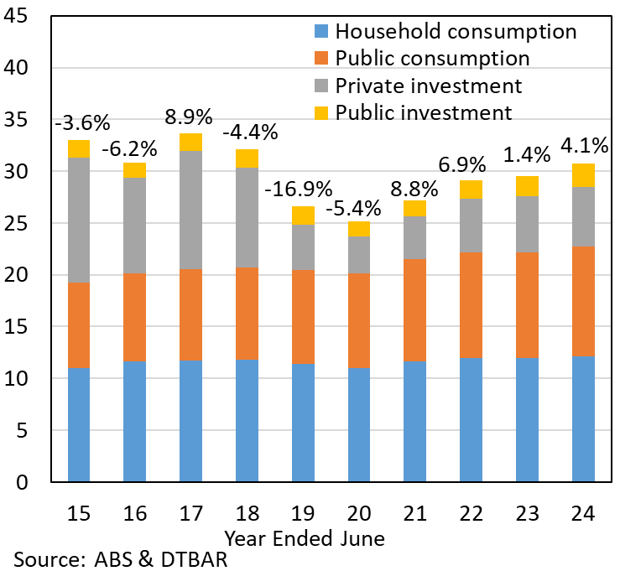 | 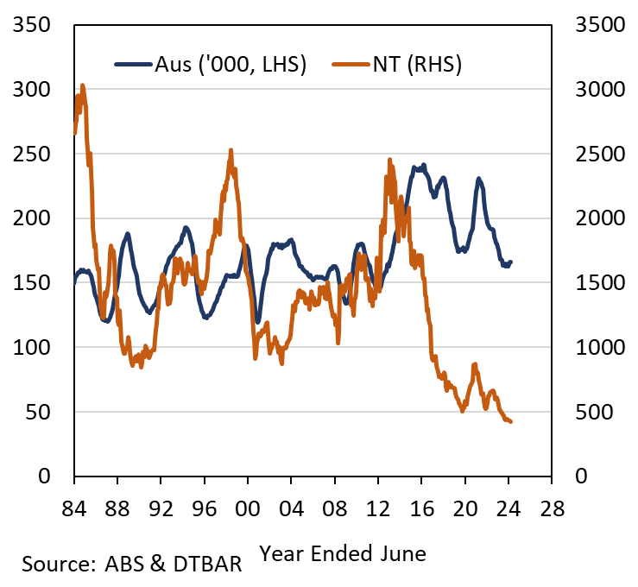
Chart 3: The slowdown in residential construction is impacting rental markets and contributing to higher rents and low vacancy rates. With steady population growth and modest rates of new construction since the late 2010s, vacancy rates have consistently been below 2%, and are currently below 1% in Darwin. Tight rental supply is supporting higher rents and yields. SQM Research reports Darwin’s rental yield is nearly 6% in August 2024, well above the national rate of 4%. | Chart 4: Investors seeking rental yield (and capital gains) are now looking north, with investor housing finance commitments up markedly in the past few years. Housing investors are likely buoyed by the Territorys’ economic outlook which is underpinned by a $65 billion pipeline of major projects. The NT Government’s recently launched HomeGrown Territory and Fresh Start New Home initiatives provide incentives for owner-occupiers and investors to construct new housing stock in the Territory.
Rental vacancy rates – Darwin vs Australia  Monthly (%) | Housing finance commitments – Darwin vs Australia  Moving annual total (number), index: June 2020 = 100
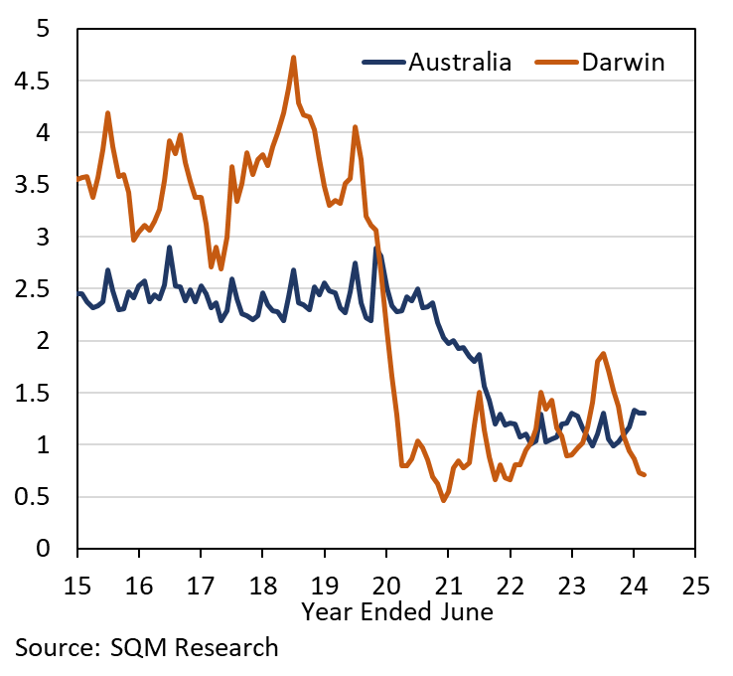 | 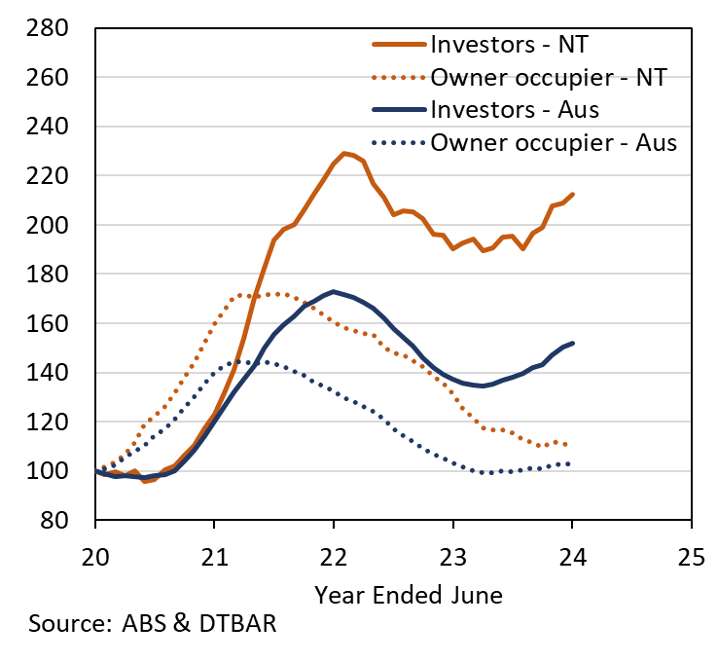

The Northern Territory of Australia exercised due care and skill to ensure that at the time of publication the information contained in this publication is true and correct. However, it is not intended to be relied on as professional advice or used for commercial purposes. The Territory gives no warranty or assurances as to the accuracy of the information contained in the publication and to the maximum extent permitted by law accepts no direct or indirect liability for reliance on its content.

